City of San Antonio
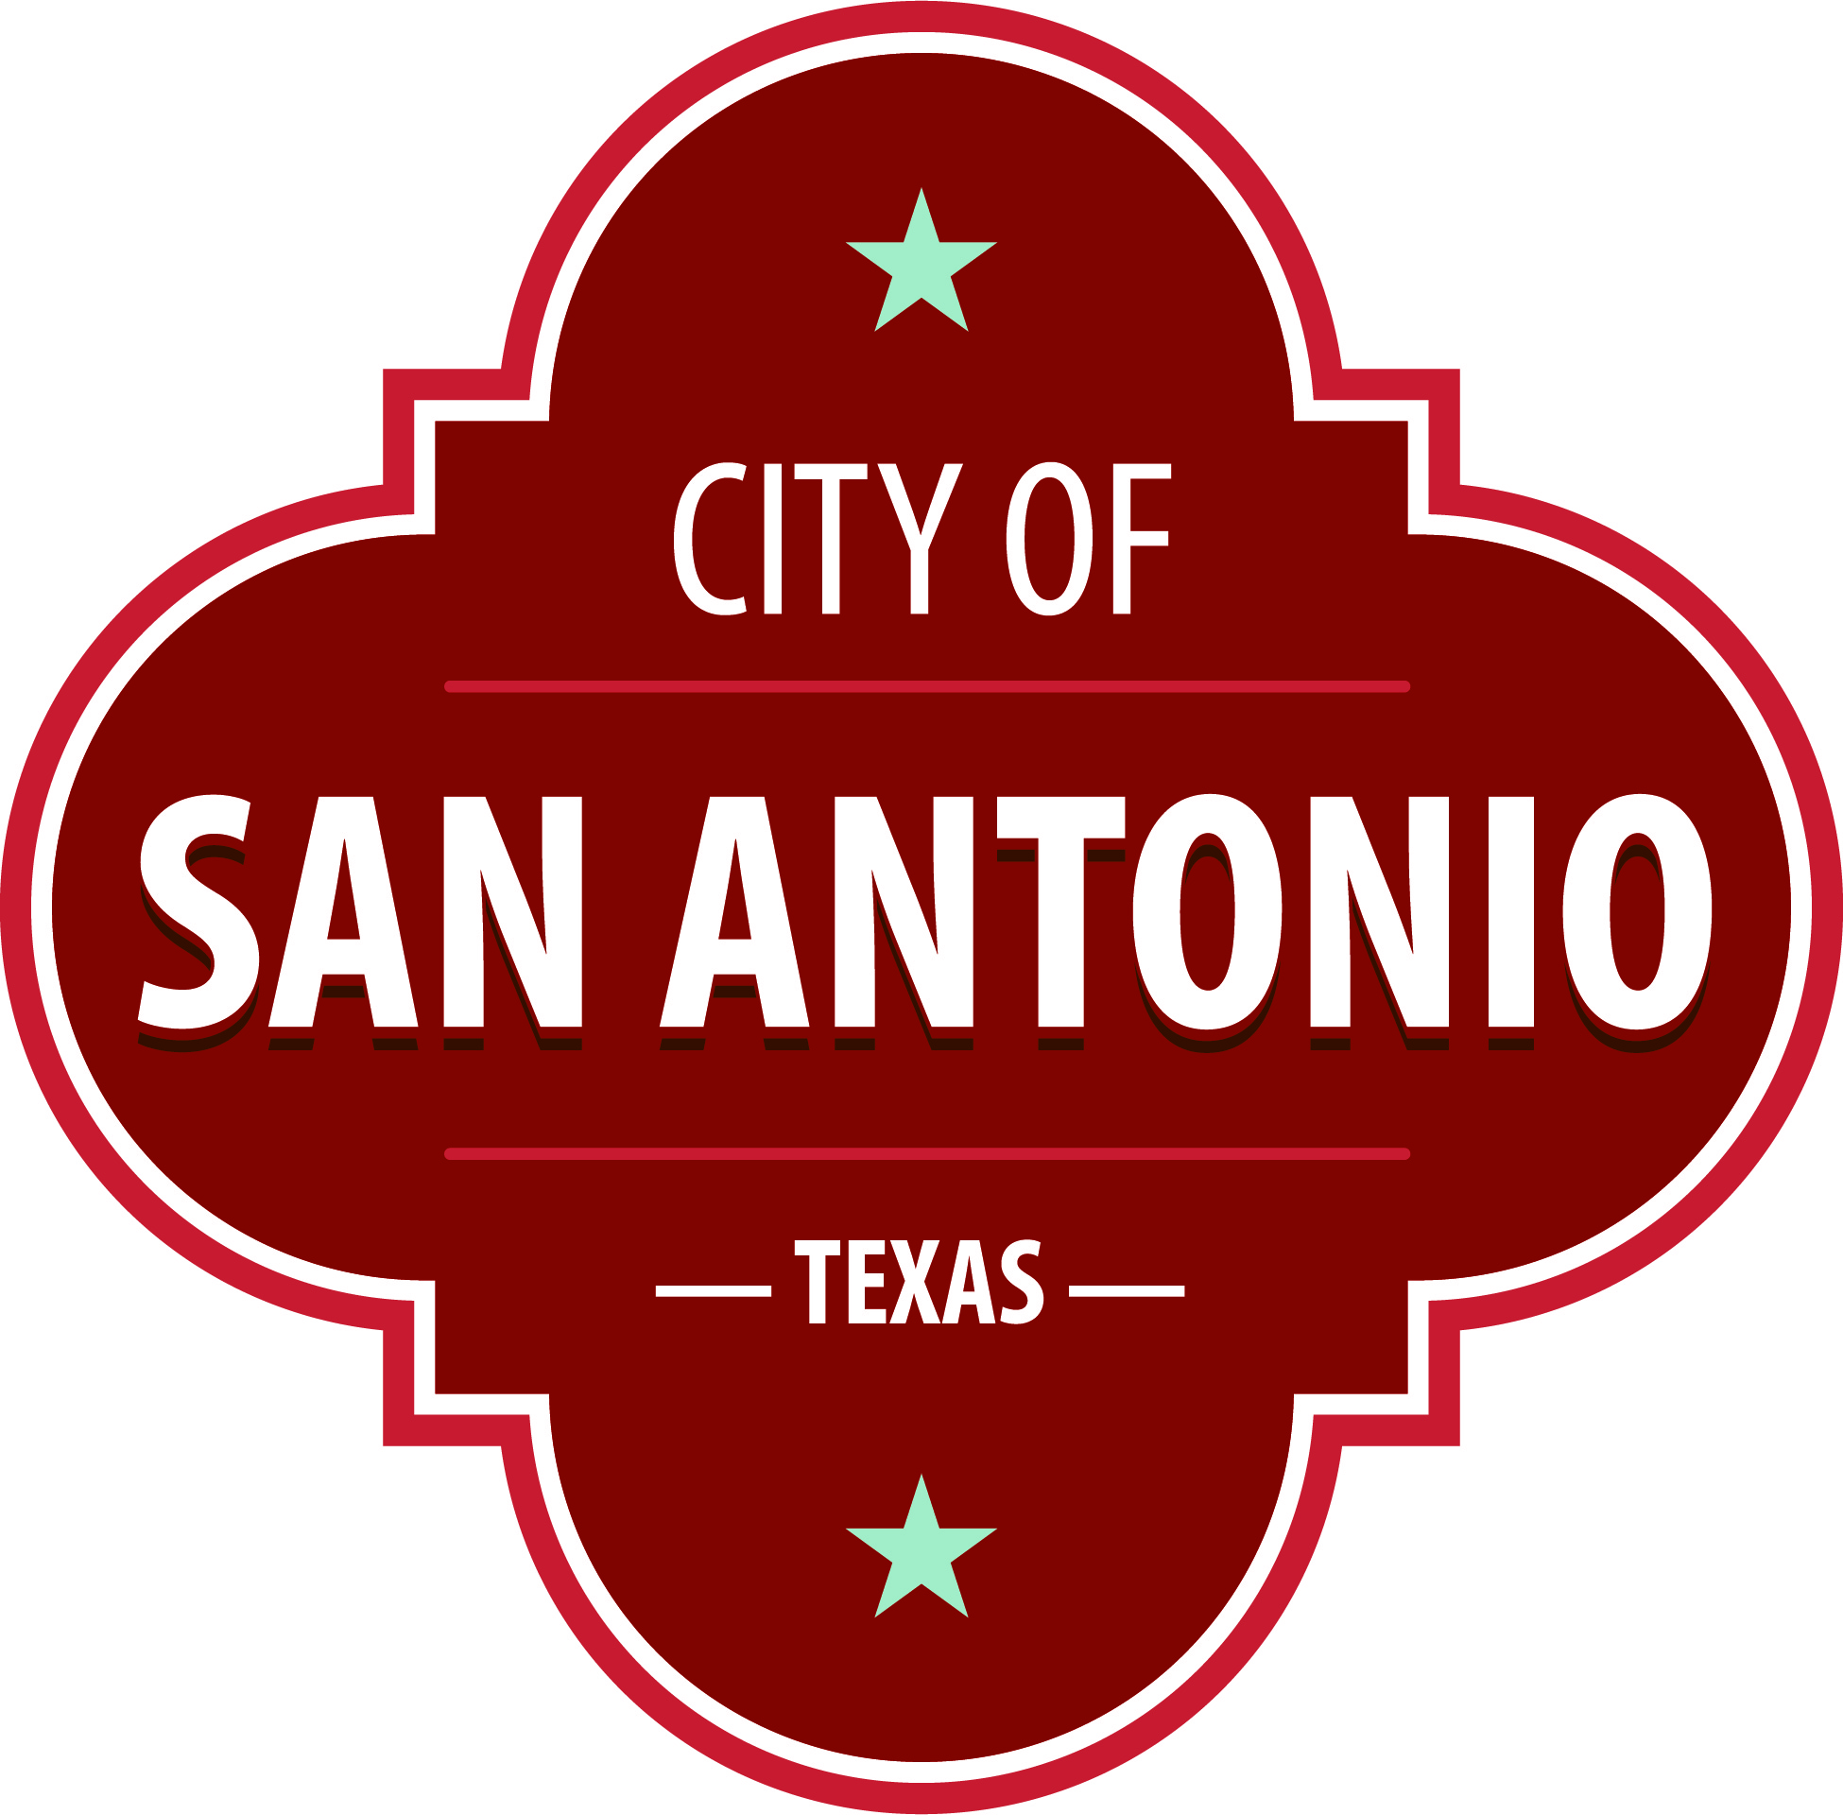
AGENDA
Community Action Advisory Board Meeting
Thursday, November 30, 2023 | 5:30 PM | Brady Head Start Building, Galaxy Conference Room, 1227 Brady Blvd, San Antonio, Texas 78207

The Community Action Advisory Board Meeting will hold its regular meeting in the Brady Head Start Building, Galaxy Conference Room, 1227 Brady Blvd, San Antonio, Texas 78207 beginning at 5:30 PM. Once convened, the Community Action Advisory Board Meeting will take up the following items no sooner than the designated times.
Once a quorum is established, the Community Action Advisory Board Meeting shall consider the following:
I. CALL REGULAR MEETING TO ORDER

II. ROLL CALL & ESTABLISHMENT OF QUORUM

Approval of Minutes
1. | Approval of the minutes from the Community Action Advisory Board meeting on October 19, 2023

Public Comments

Briefing and Possible Action on the following items
2. | Review Community Services Block Grant Performance and Fiscal Expenditure Reports

3. | Review of Texas Department of Housing and Community Affairs (TDHCA) and Texas Association of Community Action Agencies (TACAA)

4. | Review Notice of Selection of Private Organization for Community Action Advisory Board

5. | Approval of Community Action Advisory Board meeting 2024 Calendar

6. | Approval of 2023 Community Assessment

7. | Approval of Budget Amendment for the 2023-2024 Head Start and Early Head Start Budget

8. | Review of Head Start Beginning of the Year (BOY) Student Outcome Data

9. | Review of Head Start, Early Head Start (EHS), and Early Head Start- Child Care Partnership (EHS-CCP) Fiscal Report

10. | Review of Head Start, EHS, and EHS-CCP Monthly Program Report

11. | Review of Head Start Quality Assurance Report

12. | Review of EHS and EHS-CCP Quality Assurance Report

Announcements/Comments

Next CAAB Meeting January 18, 2024, Brady Head Start

At any time during the meeting, the Community Action Advisory Board Meeting may meet in executive session for consultation with the City Attorney's Office concerning attorney client matters under Chapter 551 of the Texas Government Code.
ACCESS STATEMENT
The City of San Antonio ensures meaningful access to City meetings, programs and services by reasonably providing: translation and interpretation, materials in alternate formats, and other accommodations upon request. To request these services call (210) 207-7268 or Relay Texas 711 or by requesting these services online at https://www.sanantonio.gov/gpa/LanguageServices. Providing at least 72 hours’ notice will help to ensure availability.

Posted on: 11/21/2023 10:01 AM

