City of San Antonio
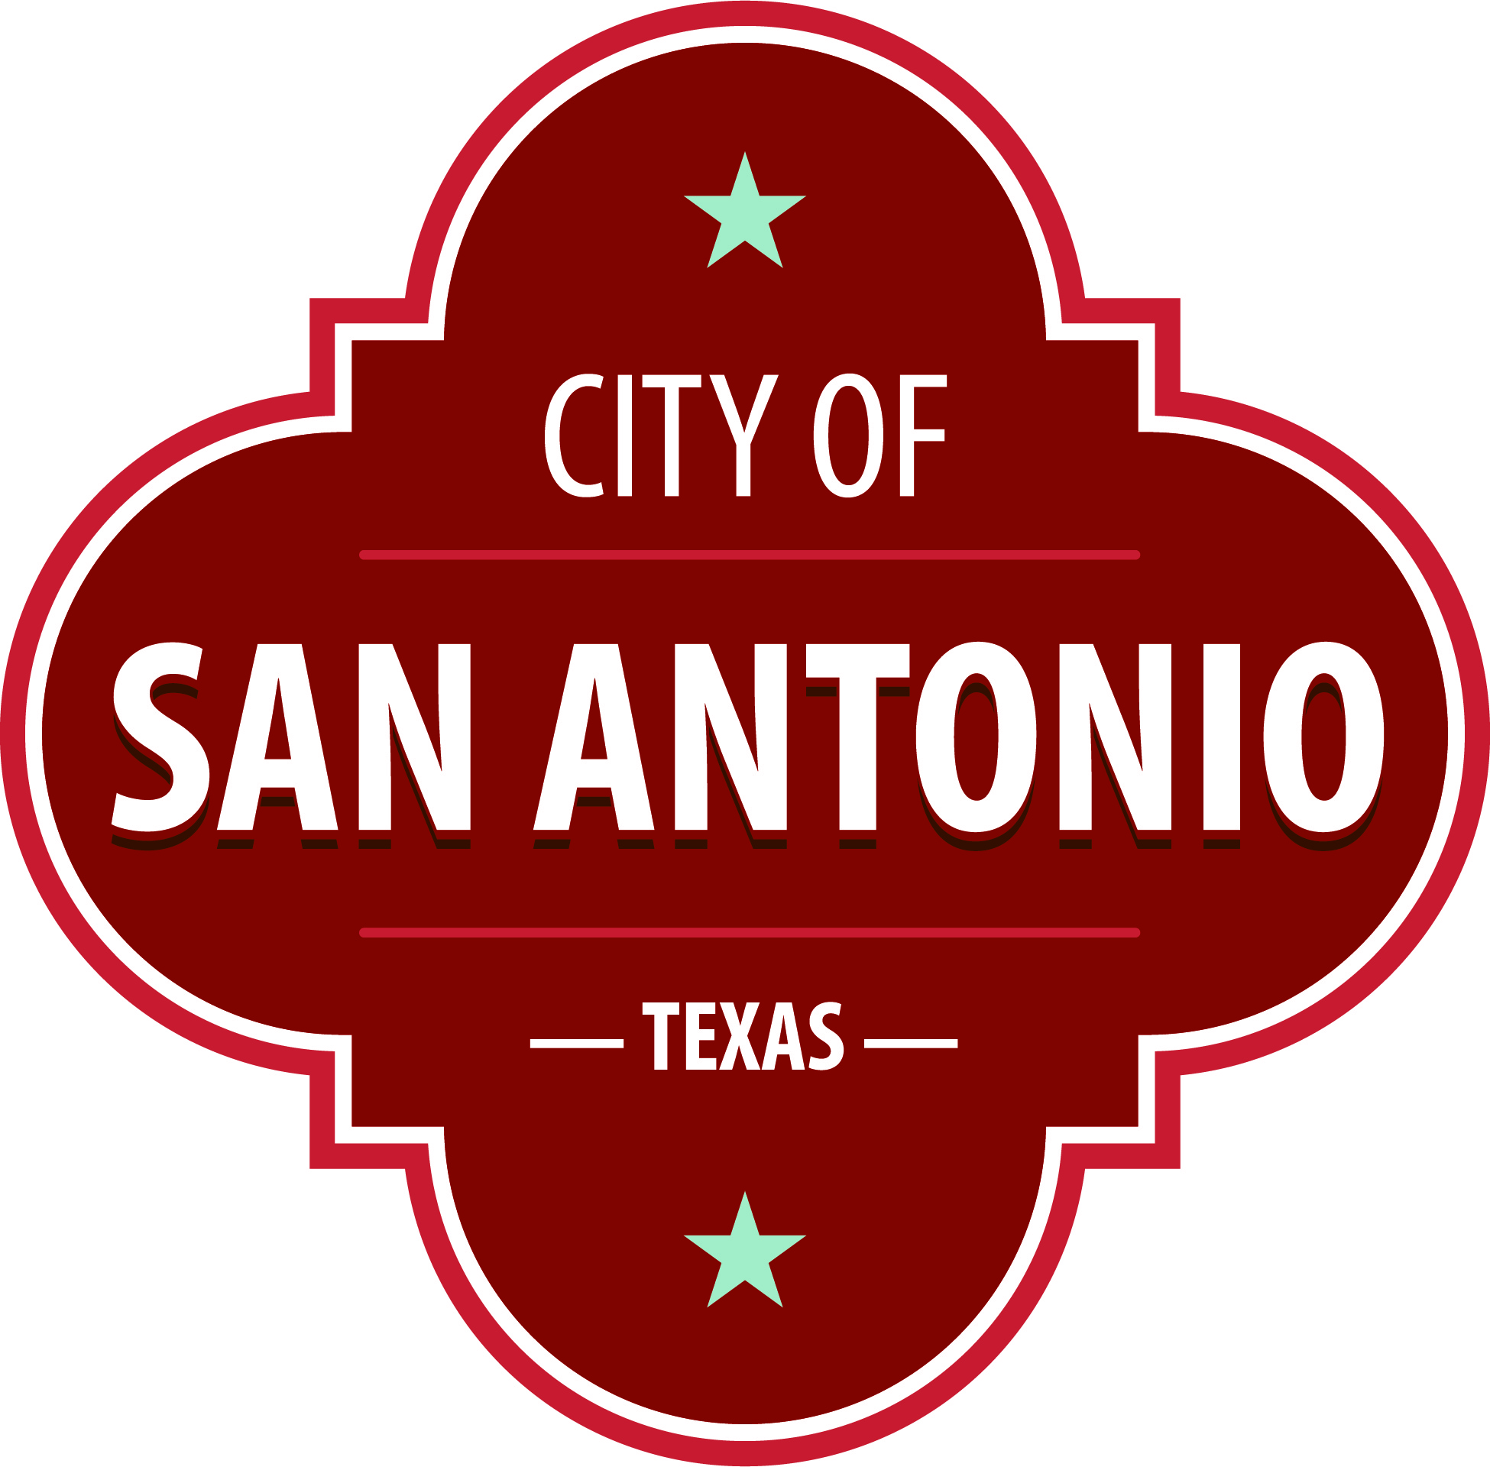
AGENDA
Parks and Recreation Board
Monday, November 28, 2022 | 5:30 PM | Municipal Plaza – B Room

A MEETING OF THE PARKS AND RECREATION BOARD WILL BE HELD IN PLAZA ROOM B OF THE MUNICIPAL PLAZA BUILDING, 114 W. COMMERCE, SAN ANTONIO, TEXAS 78205 ON MONDAY, NOVEMBER 28, 2022 AT 5:30 P.M., TO CONSIDER THE FOLLOWING MATTERS:

Members of the public may provide comment on any agenda item, consistent with procedural rules governing the Board meetings and state law. Public comments may be provided as follows:
In-Person: Sign up to speak in-person prior to the start of the meeting via the Public Comments SignUp sheet available in the meeting room location. Each speaker will be allowed a maximum of three minutes.
Written: Provide written comments (up to 300 words maximum) via email by 4:00 p.m. on the date of the meeting to Ryan.Harrison@sanantonio.gov. Please include full name and address. General comments unrelated to specific agenda items will be read during the Public Comments portion of the agenda.
Once quorum is established, the Parks and Recreation Board shall consider the following:
Approval of Minutes
1. | Approval of the minutes from the Parks and Recreation Board meeting on September 26, 2022.

Public Comments

Briefing and Possible Action on the following items
2. | Briefing Regarding 2022 Community Survey Results.

3. | Briefing Regarding Unified Development Code (UDC) Amendments.

4. | Action Regarding Parks and Recreation Board Officer Elections.

5. | Parks and Recreation Director's Report - General Departmental Updates.

ADJOURNMENT

At any time during the meeting, the Parks and Recreation Board may meet in executive session for consultation with the City Attorney's Office concerning attorney client matters under Chapter 551 of the Texas Government Code.
Parks and Recreation Board Members
District 1 – Erik Sanden
District 2 – Jennifer Ramage
District 3 – Lillian Rivera
District 4 – M. Kathy Luna (Vice-Chair)
District 5 – Agapita Jaramillo
District 6 – Bert Pickell
District 7 – Alejandro Soto
District 8 – Charles Saxer
District 9 –Collen Waguespack
District 10 – Allison Cohen (Chair)
Mayoral – Jeanette Honermann
ACCESS STATEMENT
The City of San Antonio ensures meaningful access to City meetings, programs and services by reasonably providing: translation and interpretation, materials in alternate formats, and other accomodations upon request. To request these services call (210) 207-7268 or Relay Texas 711 or by requesting these services online at https://www.sanantonio.gov/gpa/LanguageServices. Providing at least 72 hours’ notice will help to ensure availability.
DECLARACIÓN DE ACCESO
La Ciudad de San Antonio garantiza un acceso significativo a las reuniones, los programas y los servicios de la Ciudad al proporcionar razonablemente: traducción e interpretación, materiales en formatos alternativos y otras adaptaciones a pedido. Para solicitar estos servicios llame al (210) 207-7268 o Relay Texas 711 o solicite estos servicios en línea en https://www.sanantonio.gov/gpa/LanguageServices. Proporcionar un aviso de al menos 72 horas ayudará a garantizar la disponibilidad.
Posted on: 11/21/2022 03:35 PM

