City of San Antonio
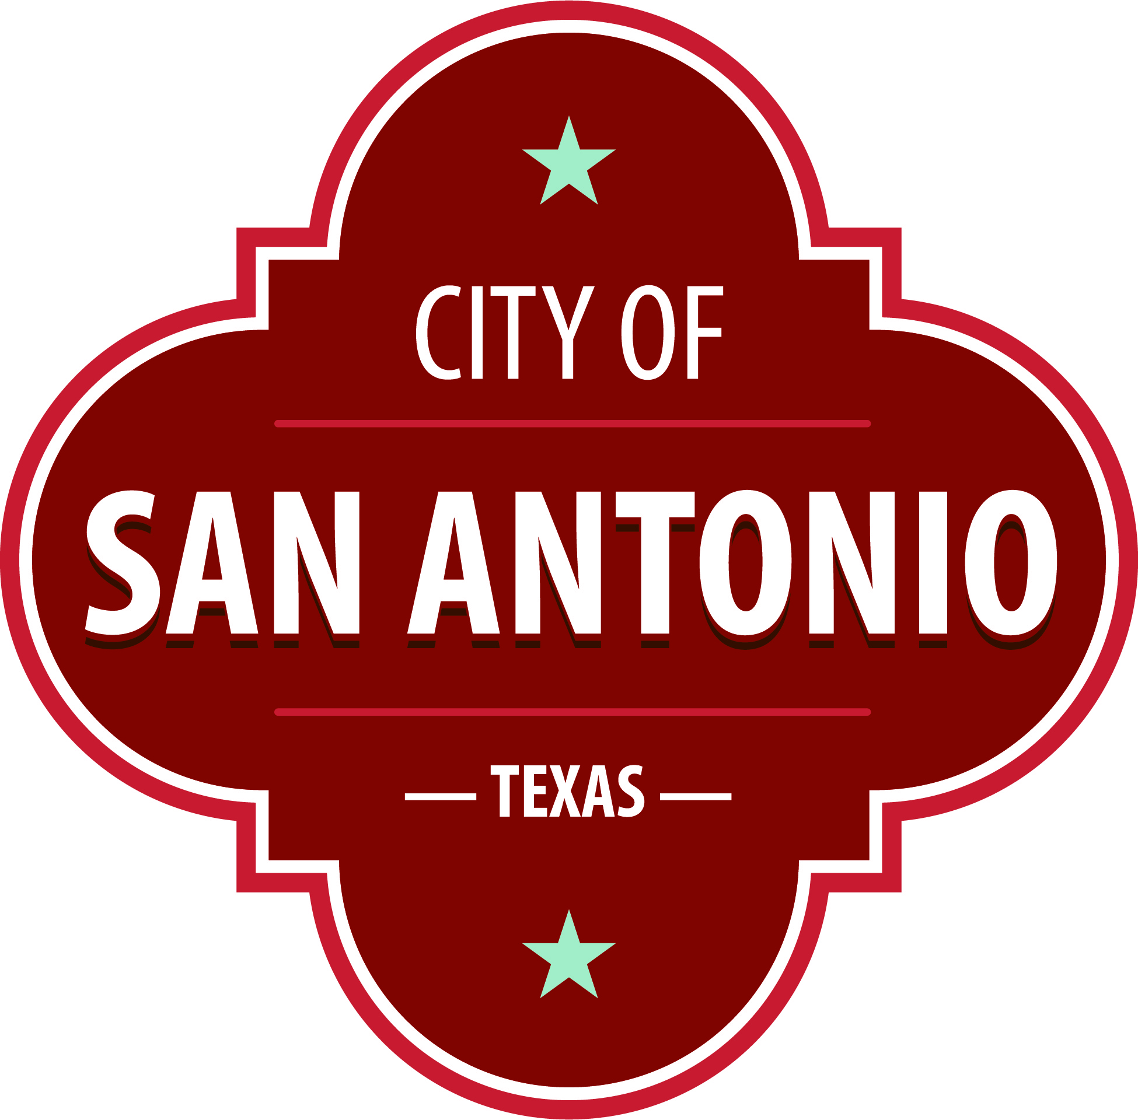
AGENDA
Transportation Advisory Board
Wednesday, August 31, 2022 | 5:00 PM | Public Safety Headquarters - Room 1403, 315 South Santa Rosa, San Antonio, TX 78207

The Transportation Advisory Board will hold its regular meeting in the Public Safety Headquarters - Room 1403, 315 South Santa Rosa, San Antonio, TX 78207 beginning at 5:00 PM.
Note: Members of the public may sign up to speak for three (3) minutes. If a member of the public has signed up, they may give their time to another speaker who has signed up. No speaker may have more than nine (9) minutes to speak.
Questions regarding this agenda notice should be directed to the Ground Transportation Unit, San Antonio Police Department, 207-7378
Once a quorum is established, the Transportation Advisory Board shall consider the following:
Approval of Minutes
1. | Approval of the minutes from the Transportation Advisory Board meeting on July 27, 2022

Public Comments

Briefing and Possible Action on the following items
2. | Update on the TAB proposed amendments to Chapter 33 and TAB chairperson

3. | Owner/Operator's ability to utilize an additional driver

4. | Charter and Limousine annual inspection process on vehicles with a seating capacity of 16 or more passengers

At any time during the meeting, the Transportation Advisory Board may meet in executive session for consultation with the City Attorney's Office concerning attorney client matters under Chapter 551 of the Texas Government Code.
ACCESS STATEMENT
The City of San Antonio ensures meaningful access to City meetings, programs and services by reasonably providing: translation and interpretation, materials in alternate formats, and other accommodations upon request. To request these services call (210) 207-7268 or Relay Texas 711 or by requesting these services online at https://www.sanantonio.gov/gpa/LanguageServices. Providing at least 72 hours’ notice will help to ensure availability.
Posted on: 08/26/2022 04:12 PM

