City of San Antonio
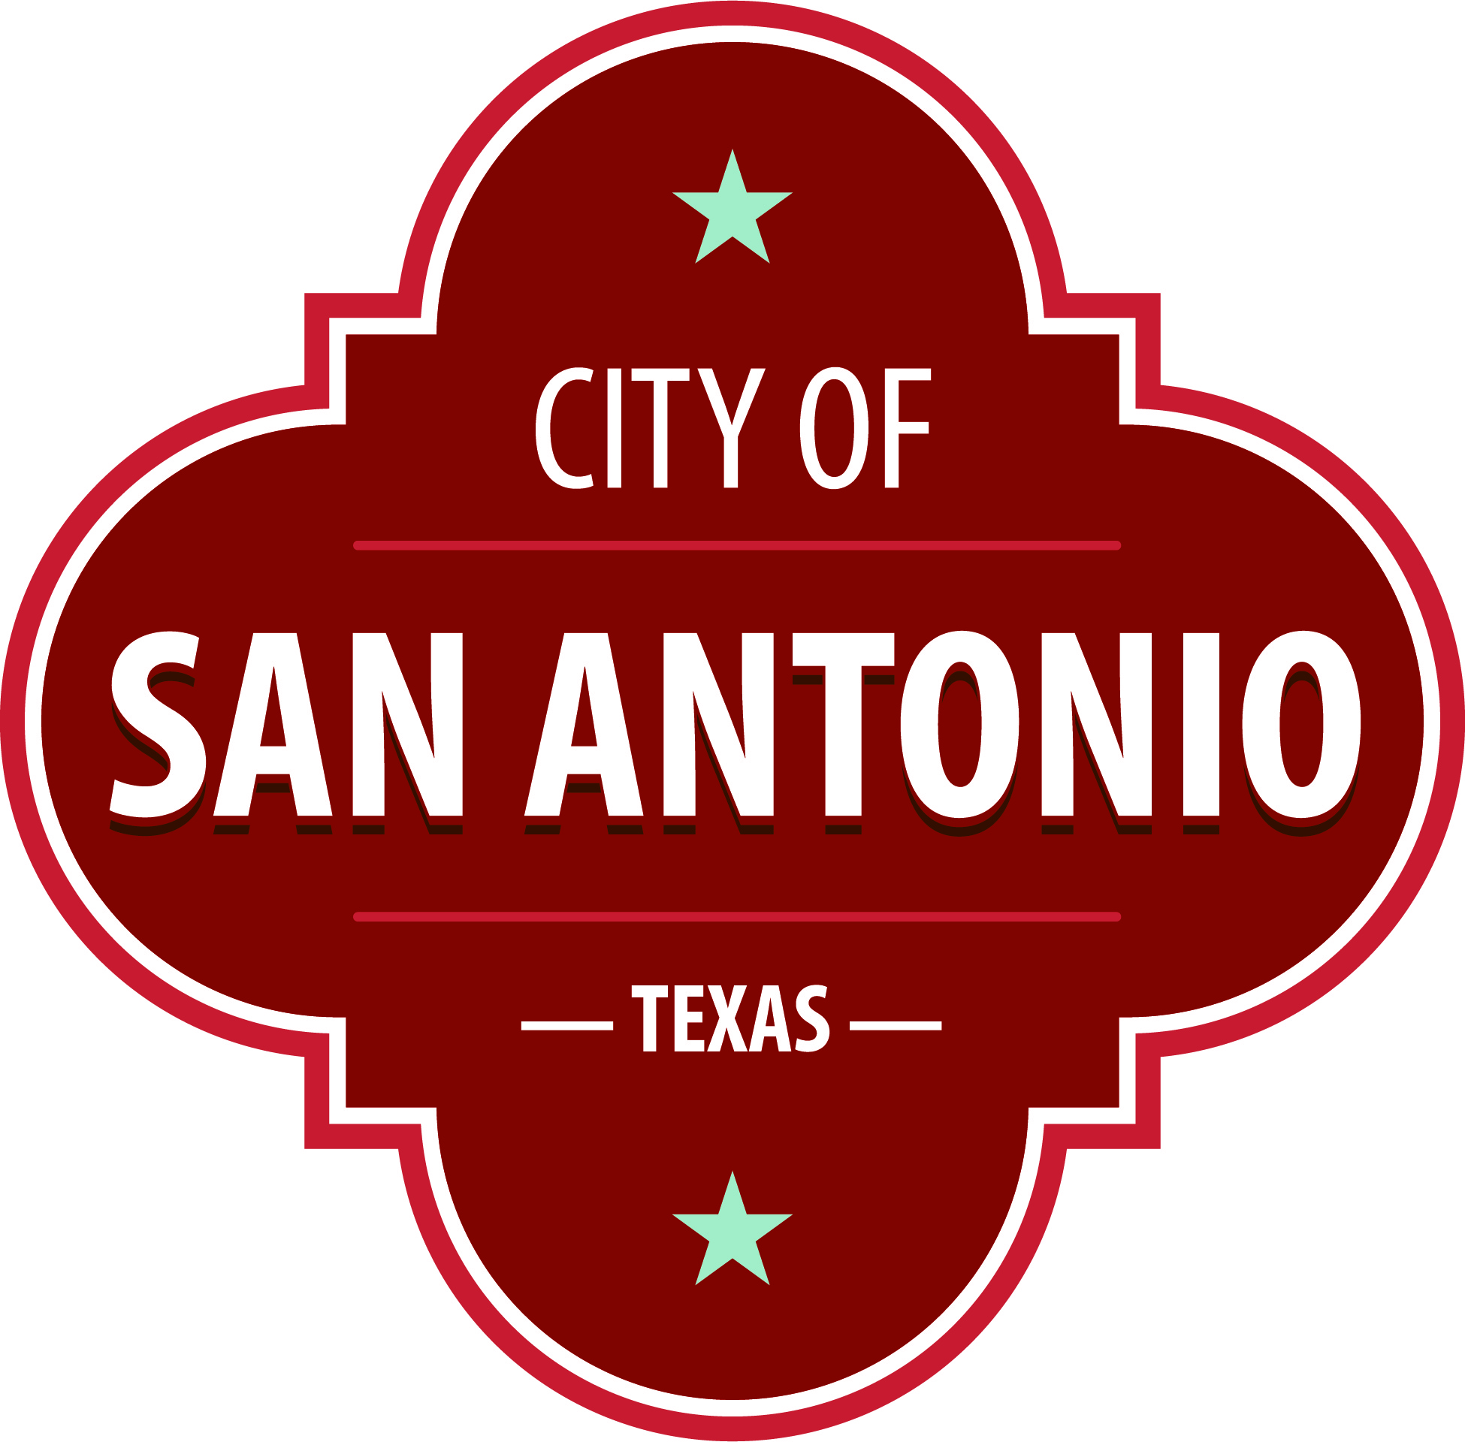
AGENDA
Community Action Advisory Board
Thursday, October 28, 2021 | 3:30 PM | 1227 Brady Blvd

The Community Action Advisory Board will hold its regular meeting in the 1227 Brady Blvd beginning at 3:30 PM. Once convened, the Community Action Advisory Board will take up the following items no sooner than the designated times.
Members of the public can comment on items on the agenda. To submit comments or sign up to speak, please go to www.sanantonio.gov/agenda and click on the eComment link for instructions. Questions relating to these rules may be directed to the Office of the City Clerk at (210) 207-7253
Once a quorum is established, the Community Action Advisory Board shall consider the following:
Call to Order

Meeting Minutes
1. Approval of Sept 9, 2021 Meeting Minutes

Public Comment

Correspondence

Briefing and Possible Action
1. Review of the 2021 Program Performance Report

2. Review of the 2021 Community Service Block Grant Budget

3. Community Service Block Grant Updates

4. Approval of the 2021 Community Assessment

5. Approval of the Early Head Start Early Head Start (EHS) request for waiver & program

6. Approval of the Head Start 1303 Application

7. Review of the Head Start Primegov.com for Community Action Advisory Board

8. Review Head Start Program Monitoring Reports

9. Review of 20-21 Head Start, Early Head Start, and Early Head Start-CCP Program Information Report

10. Review of 2022-2023 Early Head Start (EHS) Grant Application

11. Review of 2022-2023 Head Start Grant Application

12. Review of Early Head Start-CCP Temporary Program Design Modification

13. Review of Head Start, Early Head Start, and Early Head Start-CCP monthly report

14. Review of Head Start, Early Head Start, and Early Head Start-CCP Fiscal Reports

Governing Body

Announcements

Adjournment

Mission Statement
Department of Human Services Community Action Advisory Board, a forum for policy on poverty and to assure that the issues of the poor are effectively heard and addressed, and to inspire self-sufficiency in individuals and families, respecting and recognizing their desire to make a change for themselves and their families
DEPARTMENT OF HUMAN SERVICES HEAD START MISSION STATEMENT
Preparing children and engaging families for school readiness and life-long success.

At any time during the meeting, the Community Action Advisory Board may meet in executive session by videoconference for consultation with the City Attorney's Office concerning attorney client matters under Chapter 551 of the Texas Government Code.

DISABILITY ACCESS STATEMENT
This meeting site is wheelchair accessible. The Accessible Entrance is located at the Municipal Plaza Building / Main Plaza Entrance. Auxiliary Aids and Services, including Deaf interpreters, must be requested forty-eight [48] hours prior to the meeting. For assistance, call (210) 207-7268 or 711 Texas Relay Service for the Deaf.

Intérpretes en español estarán disponibles durante la junta del consejo de la ciudad para los asistentes que lo requieran. También se proveerán intérpretes para los ciudadanos que deseen exponer su punto de vista al consejo de la ciudad. Para más información, llame al (210) 207-7253

