City of San Antonio
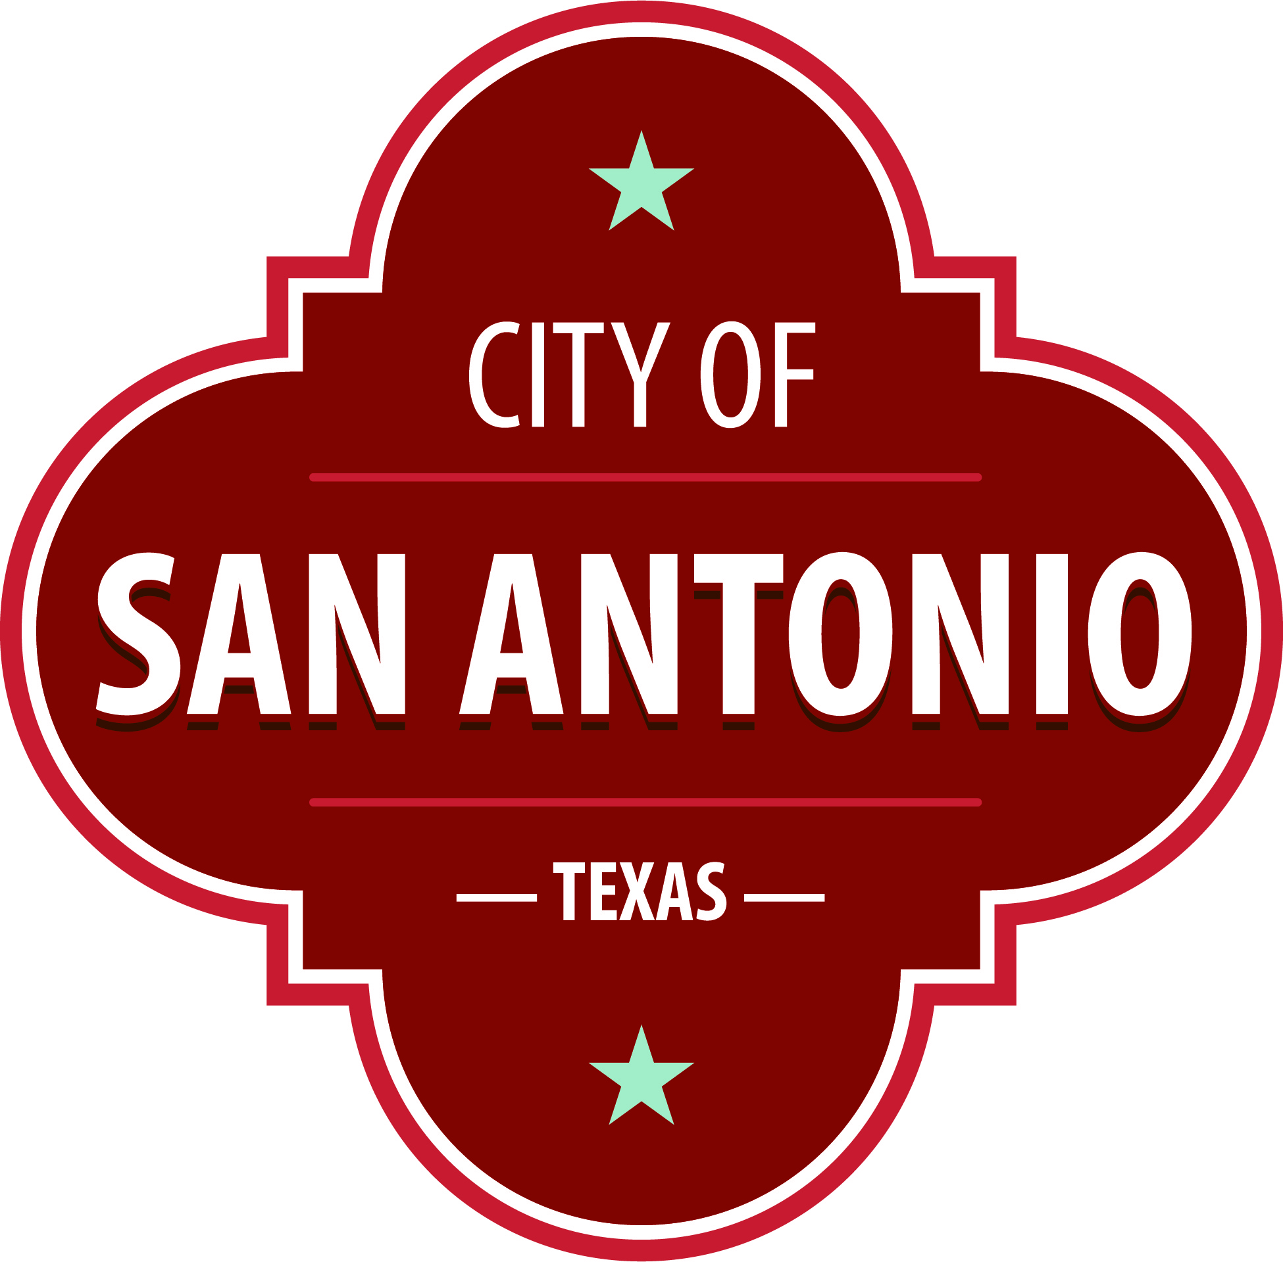
AGENDA
Community Action Advisory Board Regular Meeting
Thursday, October 6, 2022 | 5:30 PM | Brady Head Start Building, Galaxy Conference Room, 1227 Brady Blvd, San Antonio, Texas 78207

The Community Action Advisory Board Regular Meeting will hold its regular meeting in the Brady Head Start Building, Galaxy Conference Room, 1227 Brady Blvd, San Antonio, Texas 78207 beginning at 5:30 PM. Once convened, the Community Action Advisory Board Regular Meeting will take up the following items no sooner than the designated times.
Once a quorum is established, the Community Action Advisory Board Regular Meeting shall consider the following:
Approval of Minutes
1. | Approval of the minutes from the Community Action Advisory Board meeting on August 4, 2022

Public Comments

Briefing and Possible Action on the following items
2. | Review of Community Service Block Grant (CSBG) Program Updates

3. | Review of Community Service Block Grant (CSBG) Performance

4. | Review of August 2022 Community Service Block Grant (CSBG)

5. | Correspondence- ACF-IM-HS-22-05 Office of Head Start Guidance for Use of Funds Appropriated in the American Rescue Plan Act of 2021 (ARP) (Pub. L. 117-2); Accompaniment to ACF-IOAS-DCL-22-01

6. | Correspondence- ACF-IM-HS-22-06 Strategies to Stabilize the Head Start Workforce

7. | Review of Head Start Bylaws updates

8. | Review of 2022-2023 Head Start, EHS, and EHS-CCP Health Safety Screener Calendar

9. | Review of Early Head Start (EHS) and Early Head Start-Child Care Partnership (EHS-CCP) End of Year (EOY) Data

10. | Review of 2021-2022 Head Start and EHS End of Year (EOY) Family Assessment Data

11. | Review of 2022-2023 Head Start, EHS, and EHS-CCP Monitoring Calendar

12. | Review of Head Start, EHS, and EHS-CCP Fiscal Report

13. | Review of Head Start, EHS, and EHS-CCP Monthly Program Report

14. | Review of Head Start, EHS and EHS-CCP Program Monitoring

At any time during the meeting, the Community Action Advisory Board Regular Meeting may meet in executive session for consultation with the City Attorney's Office concerning attorney client matters under Chapter 551 of the Texas Government Code.
ACCESS STATEMENT
The City of San Antonio ensures meaningful access to City meetings, programs and services by reasonably providing: translation and interpretation, materials in alternate formats, and other accommodations upon request. To request these services call (210) 207-7268 or Relay Texas 711 or by requesting these services online at https://www.sanantonio.gov/gpa/LanguageServices. Providing at least 72 hours’ notice will help to ensure availability.

Posted on: 09/30/2022 11:22 AM

