City of San Antonio
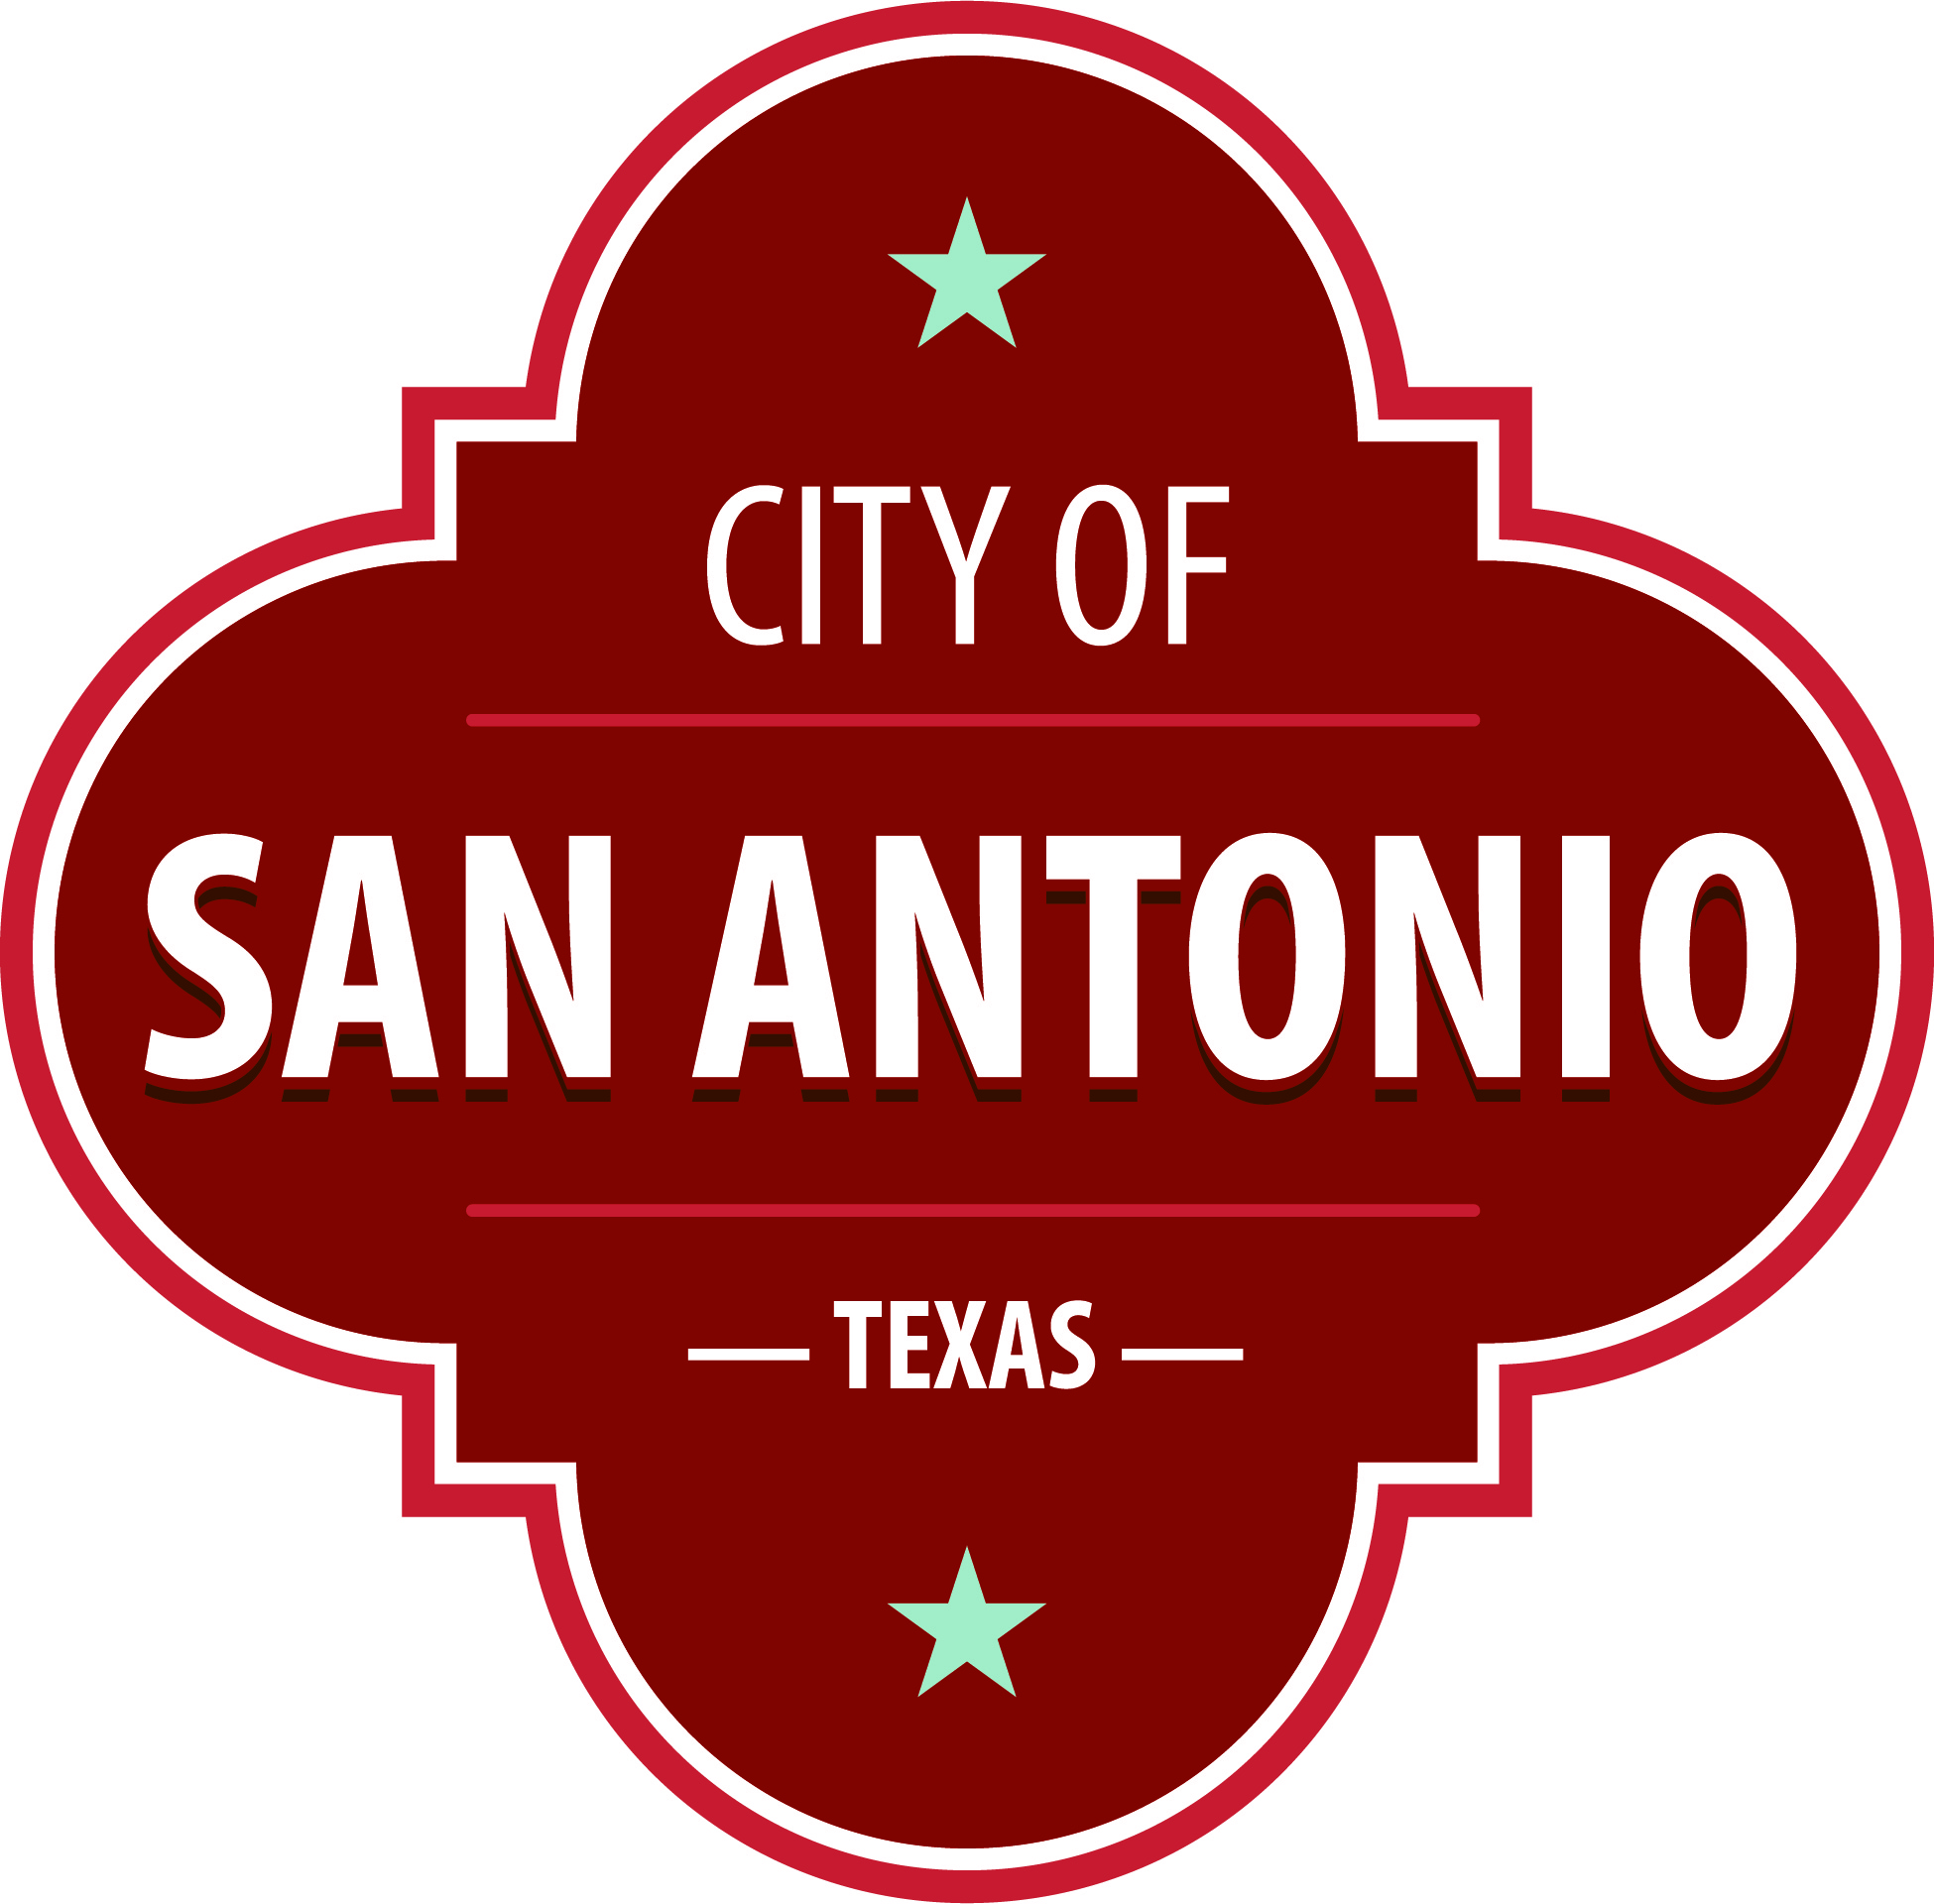
AGENDA PACKET
Community Action Advisory Board Meeting
Thursday, January 18, 2024 | 5:30 PM | Brady Head Start Building, Galaxy Conference Room, 1227 Brady Blvd, San Antonio, Texas 78207

The Community Action Advisory Board Meeting will hold its regular meeting in the Brady Head Start Building, Galaxy Conference Room, 1227 Brady Blvd, San Antonio, Texas 78207 beginning at 5:30 PM. Once convened, the Community Action Advisory Board Meeting will take up the following items no sooner than the designated times.
Members of the public can comment on items on the agenda. To submit comments or sign up to speak, please go to www.sanantonio.gov/agenda and click on the eComment link for instructions. Questions relating to these rules may be directed to the Office of the City Clerk at (210) 207-7253
Once a quorum is established, the Community Action Advisory Board Meeting shall consider the following:
Call Regular Meeting of CAAB to Order

Roll Call & Establishment of Quorum

Public Comments

Approval of Minutes
1. | Approval of the minutes from the Community Action Advisory Board meeting on November 30, 2023

Briefing and Possible Action on the following items
2. | Review of 2023 December CSBG Fiscal Expenditure Report

3. | Review 2023 CSBG Budget Revision

4. | Review 2023 CSBG Discretionary Budget

5. | TDHCA/Family Assistance Updates

6. | Review CAAB Vacancies for Private Organizations

7. | Review 2024 CAAB Calendar

8. | Review Annual Governance Training for CAAB

9. | Correspondence – ACF-PI-OHS-23-04 Notice of Proposed Rulemaking (NPRM) on Supporting the Head Start Workforce and Consistent Quality Programming – Public Comment Period

10. | Correspondence - HSES Enrollment - 06CH010821 - EHS Underenrollment Letter

11. | Approval of the 2024-2025 Head Start Eligibility, Recruitment, Selection, Enrollment and Attendance (ERSEA) Matrix

12. | Approval of the 2024-2025 Early Head Start (EHS) and Early Head Start-Child Care Partnership (EHS-CCP) ERSEA Matrix

13. | Approval of the 2024-2025 Head Start ERSEA Policy Updates

14. | Approval of the 2024-2025 Early Head Start and Early Head Start-Child Care Partnership (EHS-CCP) ERSEA Policy Updates

15. | Approval of the 2024-2025 Head Start and Early Head Start ERSEA Recruitment Plan

16. | Review of Head Start, Early Head Start (EHS), and Early Head Start-Child Care Partnership (EHS-CCP) Fiscal Report

17. | Review of Head Start, EHS, and EHS-CCP Monthly Program Report

18. | Review of Head Start Quality Assurance Report

19. | Review of EHS and EHS-CCP Quality Assurance Report

Announcements

CAAB Board next Meeting-February 15, 2024

At any time during the meeting, the Community Action Advisory Board Meeting Committee may meet in executive session by videoconference for consultation with the City Attorney's Office concerning attorney client matters under Chapter 551 of the Texas Government Code.
Attachments not included.
Attachments cannot be added to a DOCX compile.

