City of San Antonio
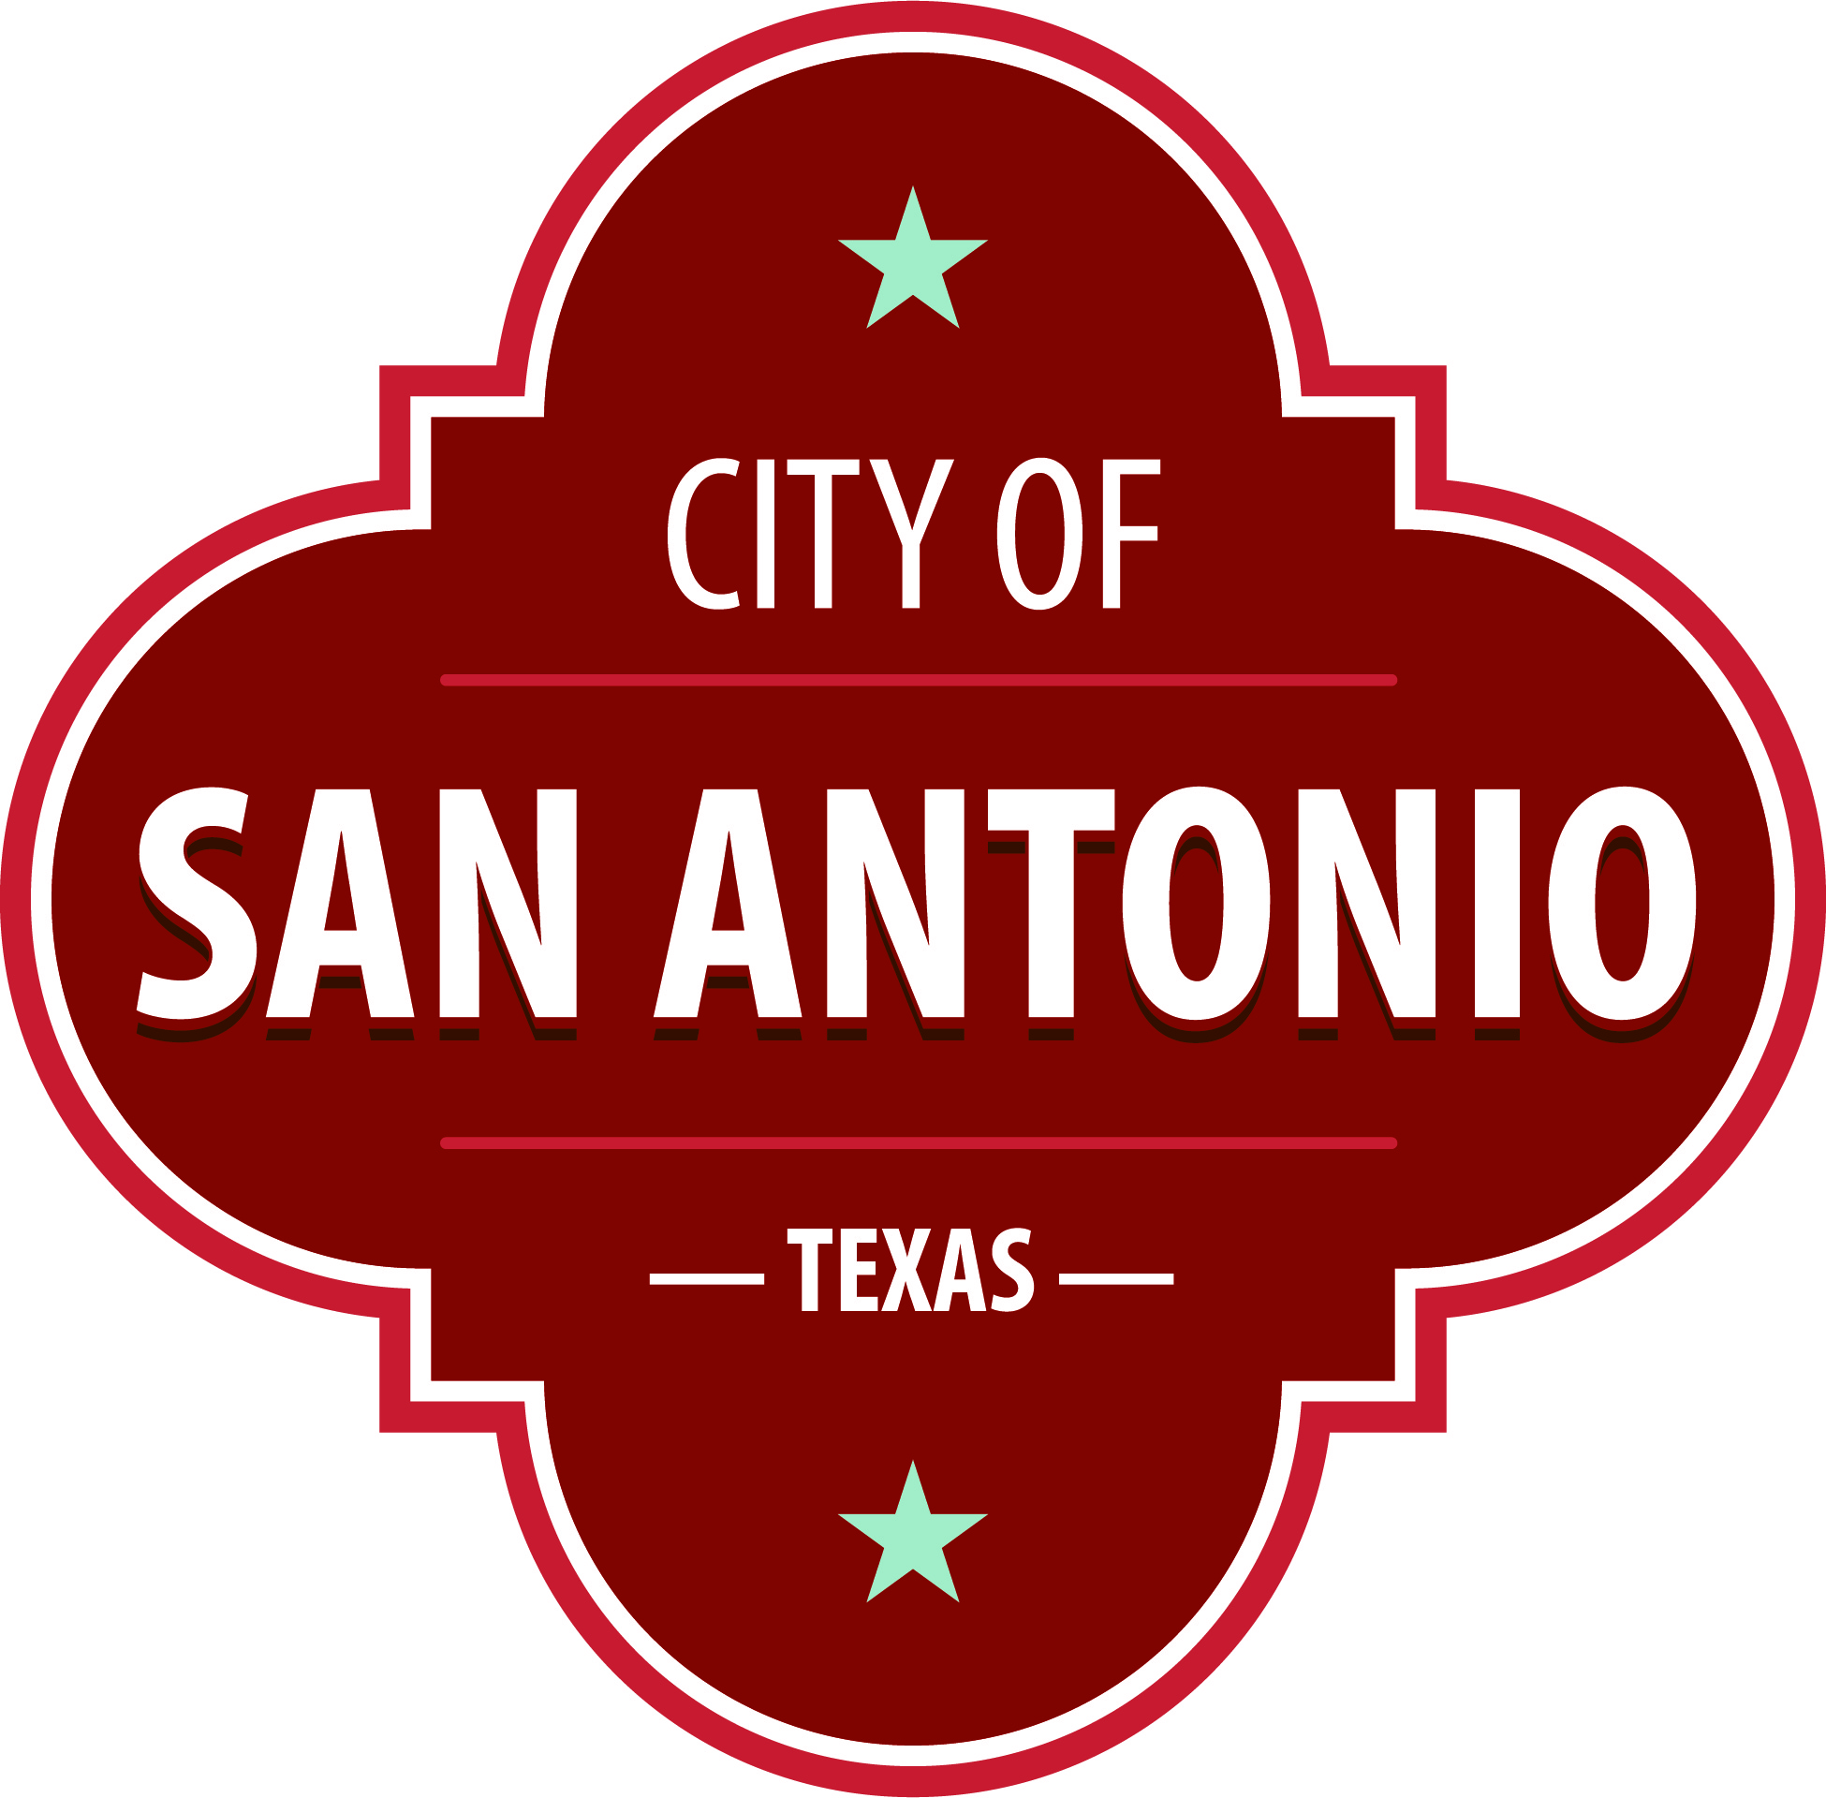
AGENDA
Community Action Advisory Board Meeting
Thursday, December 15, 2022 | 5:30 PM | Brady Head Start Building, Galaxy Conference Room, 1227 Brady Blvd, San Antonio, Texas 78207

The Community Action Advisory Board Meeting will hold its regular meeting in the Brady Head Start Building, Galaxy Conference Room, 1227 Brady Blvd, San Antonio, Texas 78207 beginning at 5:30 PM. Once convened, the Community Action Advisory Board Meeting will take up the following items no sooner than the designated times.
Once a quorum is established, the Community Action Advisory Board Meeting shall consider the following:
Approval of Minutes
1. | Approval of the minutes from the meeting on {November 17, 2022}

Public Comments

Briefing and Possible Action on the following items
2. | Community Service Block Grant (CSBG) Performance and Fiscal Expenditure Reports

3. | 2023 Community Service Block Grant Ordinance Update.

4. | Review Notice of Vacancies for Low Income Representatives

5. | Texas Department of Housing and Community Affairs (TDHCA) and Training for Job Success (TFJS) Updates

6. | Approval of 2022 Community Assessment

7. | Approval of Head Start Program Five-Year Strategic Plan

8. | Approval of the 2023-2024 Head Start and Early Head Start Program Eligibility, Recruitment, Selection, Enrollment, and Attendance (ERSEA) Policy Updates

9. | Approval of the 2023-2024 Head Start and Early Head Start Program ERSEA Recruitment Plan

10. | Review of 2022-2023 Election of Head Start Policy Council Officers

11. | Review of Head Start, Early Head Start (EHS), and Early Head Start-Child Care Partnership (EHS-CCP) Fiscal Report

12. | Review of Head Start, EHS, and EHS-CCP Monthly Program Report

13. | Review of Head Start Program Monitoring

14. | Correspondence – ACF-IM-HS-22-08 Fiscal Year (FY) 2023 Monitoring Process for Head Start and Early Head Start Recipients

15. | Correspondence – ACF-IM-HS-22-09 Enrollment Reductions and Conversions of Head Start Slots to Early Head Start Slots

At any time during the meeting, the Community Action Advisory Board Meeting may meet in executive session for consultation with the City Attorney's Office concerning attorney client matters under Chapter 551 of the Texas Government Code.
ACCESS STATEMENT
The City of San Antonio ensures meaningful access to City meetings, programs and services by reasonably providing: translation and interpretation, materials in alternate formats, and other accommodations upon request. To request these services call (210) 207-7268 or Relay Texas 711 or by requesting these services online at https://www.sanantonio.gov/gpa/LanguageServices. Providing at least 72 hours’ notice will help to ensure availability.

Posted on: 12/12/2022 08:06 AM

