City of San Antonio
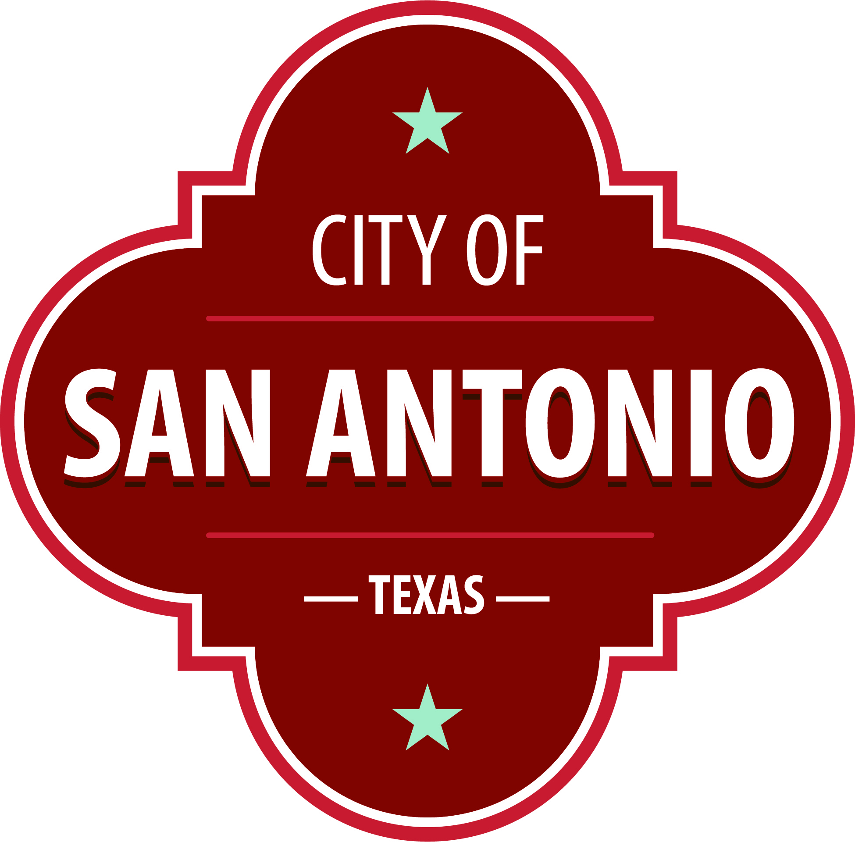
AGENDA
City Council Special Session
Norma S. Rodriguez Council Chamber
Municipal Plaza Building
114 W. Commerce Street
San Antonio, Texas 78205
Tuesday, August 2, 2022 | 1:00 PM | Municipal Plaza Building

The City Council will hold a special meeting beginning at the above referenced date and time for the following items. Once convened, the City Council will take up the following items in any order during the meeting but no sooner than the designated times.

1:00PM: Call to Order

Members of the public can comment on items on the agenda. To sign up to speak visit www.saspeakup.com before the start time of 1:00pm. Click on meetings and events and select the meeting you’d like to participate in. Sign up to speak or submit a written comment. You can also sign up to speak in-person at the meeting location, before the start time of 1:00pm. Questions relating to these rules may be directed to the Office of the City Clerk at (210) 207-7253.
Individuals signing up for public comment may register for VIA bus fare or parking validation at www.saspeakup.com. VIA bus fare or parking at City Tower Garage (located at 100 Blk N. Main) will be provided to individuals who request the assistance. Staff will provide VIA bus fare passes and parking validation tickets in the lobby of City Council Chambers.
To view the Live meeting please view our Live Stream

During the meeting, the City Council may meet in executive session for consultation with the City Attorney's Office concerning attorney-client matters under Chapter 551 of the Texas Government Code.
ACCESS STATEMENT
The City of San Antonio ensures meaningful access to City meetings, programs and services by reasonably providing: translation and interpretation, materials in alternate formats, and other accommodations upon request. To request these services call (210) 207-2098 or Relay Texas 711 or by requesting these services online at https://www.sanantonio.gov/gpa/LanguageServices. Providing at least 72 hours’ notice will help to ensure availability.

Intérpretes en español estarán disponibles durante la junta del consejo de la ciudad para los asistentes que lo requieran. También se proveerán intérpretes para los ciudadanos que deseen exponer su punto de vista al consejo de la ciudad. Para más información, llame al (210) 207-7253
For additional information on any item on this agenda, please visit www.sanantonio.gov or call (210) 207-7080.
ITEMS
1. | 2022-08-02-0034R  Resolution of the City of San Antonio to Support Individual’s Rights to Health Care

EXECUTIVE SESSION
A. | Economic development negotiations pursuant to Texas Government Code Section 551.087 (economic development)

B. | The purchase, exchange, lease or value of real property pursuant to Texas Government Code Section 551.072 (real property).

C. | Legal issues related to collective bargaining pursuant to Texas Government Code Section 551.071 (consultation with attorney).

D. | Legal issues related to litigation involving the City pursuant to Texas Government Code Section 551.071 (consultation with attorney).

E. | Legal issues relating to COVID-19 preparedness pursuant to Texas Government Code Section 551.071 (consultation with attorney).

ADJOURNMENT

THE CITY COUNCIL MAY RECESS AND RECONVENE TO CONSIDER ANY UNFINISHED COUNCIL BUSINESS
Posted on: 09/12/2022 04:16 PM

