City of San Antonio
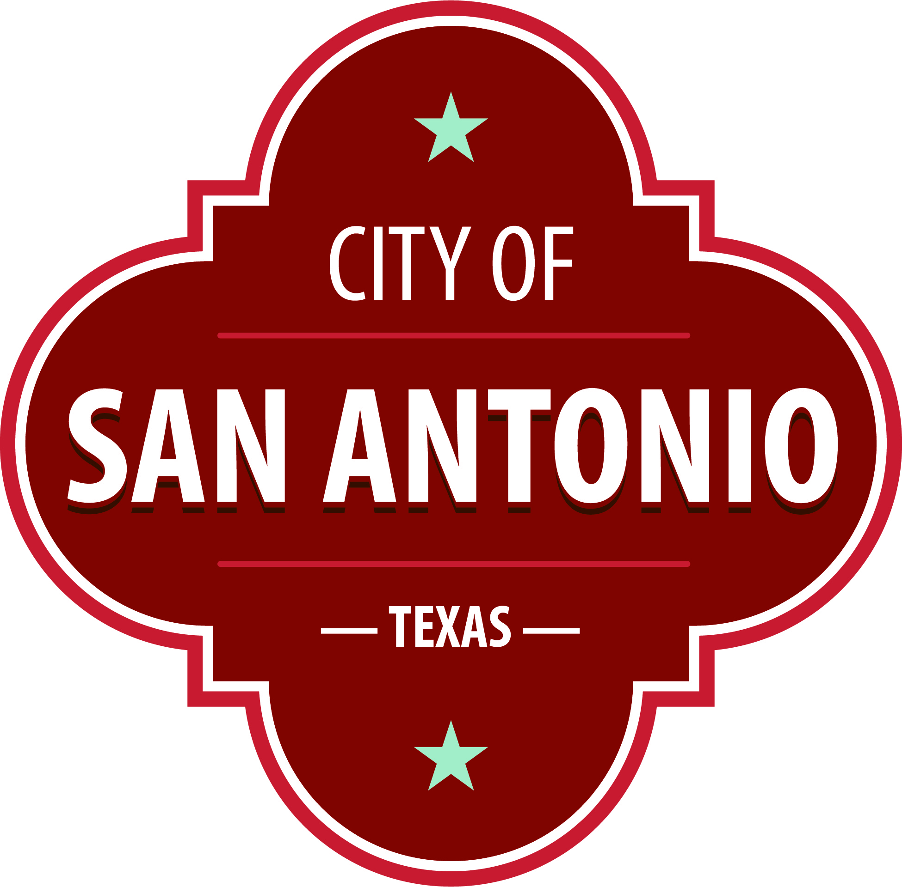
AGENDA
Community Action Advisory Board Meeting
Thursday, March 17, 2022 | 3:30 PM | Brady Head Start Building, Galaxy Conference Room, 1227 Brady Blvd, San Antonio, Texas 78207

The Community Action Advisory Board Meeting will hold its regular meeting in the Brady Head Start Building, Galaxy Conference Room, 1227 Brady Blvd, San Antonio, Texas 78207 beginning at 3:30 PM. Once convened, the Community Action Advisory Board Meeting will take up the following items no sooner than the designated times.
Once a quorum is established, the Community Action Advisory Board Meeting shall consider the following:
Approval of Minutes
1. | Approval of the minutes from the Community Action Advisory Board meeting on February 24, 2022

Public Comments

Briefing and Possible Action on the following items
2. | Review of Community Service Block Grant Fiscal Update

3. | Review Training for Job Success Program Updates

4. | Review of the Head Start, Early Head Start (EHS) and Early Head Start Child Care Partnership Program (EHSCCP) Assessment and Goal Setting

5. | Review of Head Start, EHS, and EHS-CCP Program Monitoring

6. | Review of Head Start, EHS, and EHS-CCP Monthly Program Report

7. | Review of Head Start, EHS, and EHS-CCP Fiscal Report

8. | Correspondence- Final Rule on Flexibility for Head Start Designation Renewals in Certain Emergencies

At any time during the meeting, the Community Action Advisory Board Meeting may meet in executive session for consultation with the City Attorney's Office concerning attorney client matters under Chapter 551 of the Texas Government Code.

DISABILITY ACCESS STATEMENT
This meeting site is wheelchair accessible. Auxiliary Aids and Services, including Deaf interpreters, must be requested forty-eight [48] hours prior to the meeting. For assistance, call (210) 207-7268 or 711 Texas Relay Service for the Deaf.

Posted on: 03/14/2022 11:58 AM

