City of San Antonio
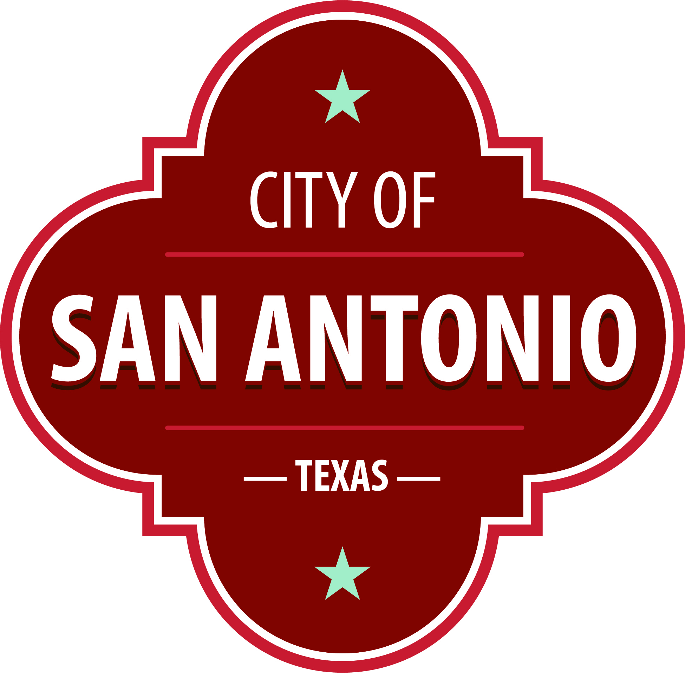
AGENDA
City of San Antonio Higher Education Student Advisory Board Meeting
Monday, May 6, 2024 | 5:30 PM | BiblioTech EDU  626 N Flores St,  San Antonio, TX 78205

The City of San Antonio Higher Education Student Advisory Board Meeting will hold its regular meeting at BiblioTech EDU 626 N Flores St, San Antonio, TX 78205 beginning at 5:30 PM. Once convened, the City of San Antonio Higher Education Student Advisory Board Meeting will take up the following items no sooner than the designated times.
The commission meetings are open to the public. Members of the public can attend the commission meetings and comment on items on the agenda.
Public Comment: Citizens can sign up before the meeting starts to speak on an agenda item. Citizens who wish to have their public comments read at the next meeting must submit their comments at least 24 hours prior to the meeting. Citizens who wish to submit comments and have them read at the meeting, may send them via email or by leaving a message. Please include your full name, address, item you are addressing and your comments.
Email: Please email the comments to camryn.blackmon@sanantonio.gov. Emails will be read at the meeting.
Voicemail: You may call (210) 207-1763 and leave a voicemail. Messages will be transcribed and read at the meeting.
Approval of Minutes
1. | Approval of the minutes from the City of San Antonio Higher Education Student Advisory Board meeting on April 15, 2024.

Public Comments

Briefing and Possible Action on the following items
2. | Chair Update

3. | Subcommittee Updates

4. | Board Vacancy Letter

5. | HESAB Logo and Flyer with Resources

6. | Update from City Staff on HESAB Social Media Policy

7. | Discussion on Policy Recommendation Ideas

8. | Goals for 2024-2025 Term

At any time during the meeting, the City of San Antonio Higher Education Student Advisory Board Meeting may meet in executive session for consultation with the City Attorney's Office concerning attorney client matters under Chapter 551 of the Texas Government Code.
ACCESS STATEMENT
The City of San Antonio ensures meaningful access to City meetings, programs and services by reasonably providing: translation and interpretation, materials in alternate formats, and other accommodations upon request. To request these services call (210) 207-1467 or Relay Texas 711 or by requesting these services online at https://www.sanantonio.gov/gpa/LanguageServices. Providing at least 72 hours’ notice will help to ensure availability.

Posted on: 04/24/2024 09:42 AM

