City of San Antonio
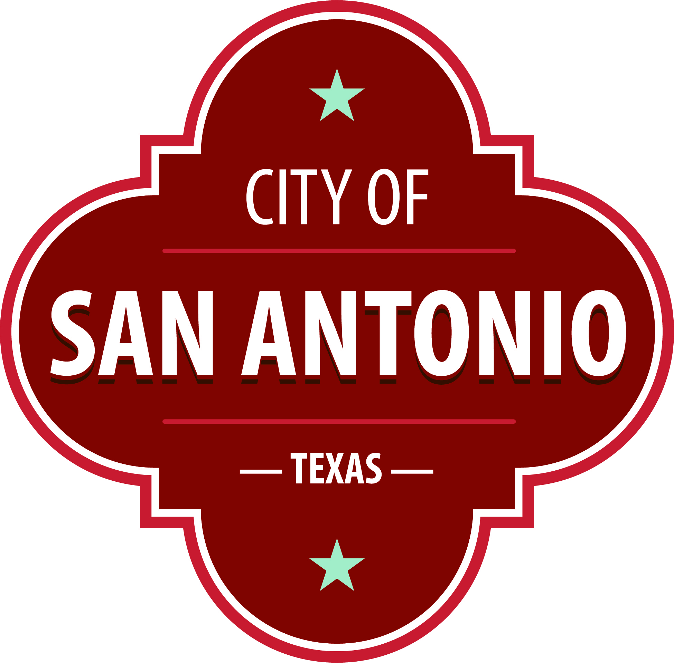
AGENDA PACKET
Animal Care Services Advisory Board Meeting
Wednesday, January 18, 2023 | 5:55 PM | 4710 State Hwy 151

The Animal Care Services Advisory Board Meeting will hold its regular meeting in the 4710 State Hwy 151 beginning at 5:55 PM. Once convened, the Animal Care Services Advisory Board Meeting will take up the following items no sooner than the designated times.
Members of the public can comment on items on the agenda. To submit comments or sign up to speak, please go to www.sanantonio.gov/agenda and click on the eComment link for instructions. Questions relating to these rules may be directed to the Office of the City Clerk at (210) 207-7253
Once a quorum is established, the Animal Care Services Advisory Board Meeting shall consider the following:
Chair's Statement

Director's Report

Consent Agenda
1. | Approval of the minutes from the Animal Care Services Advisory Board Meeting on November 17, 2022

2. | Approval of Animal Care Services Advisory Board Statistical Reports for December 2022

3. | Approval of Animal Care Services Advisory Board Contracts Performance Report

4. | Approval of Animal Care Services Advisory Board FY 2023 First Quarter Report

5. | Approval of the Animal Care Services Advisory Board Facility Inspections

6. | Approval of the Revised Fiscal Year 2023 Facility Inspection Schedule

Briefing and Possible Action on the following items
7. | Briefing on the Spay Neuter Network

8. | Briefing on the Development of the New Animal Care Services Strategic Plan

9. | Briefing on Animal Care Services Operations Update

Public Comments

Determination of Next Meeting Date

Adjournment

At any time during the meeting, the Animal Care Services Advisory Board Meeting Committee may meet in executive session by videoconference for consultation with the City Attorney's Office concerning attorney client matters under Chapter 551 of the Texas Government Code.
Attachments not included.
Attachments cannot be added to a DOCX compile.

