City of San Antonio
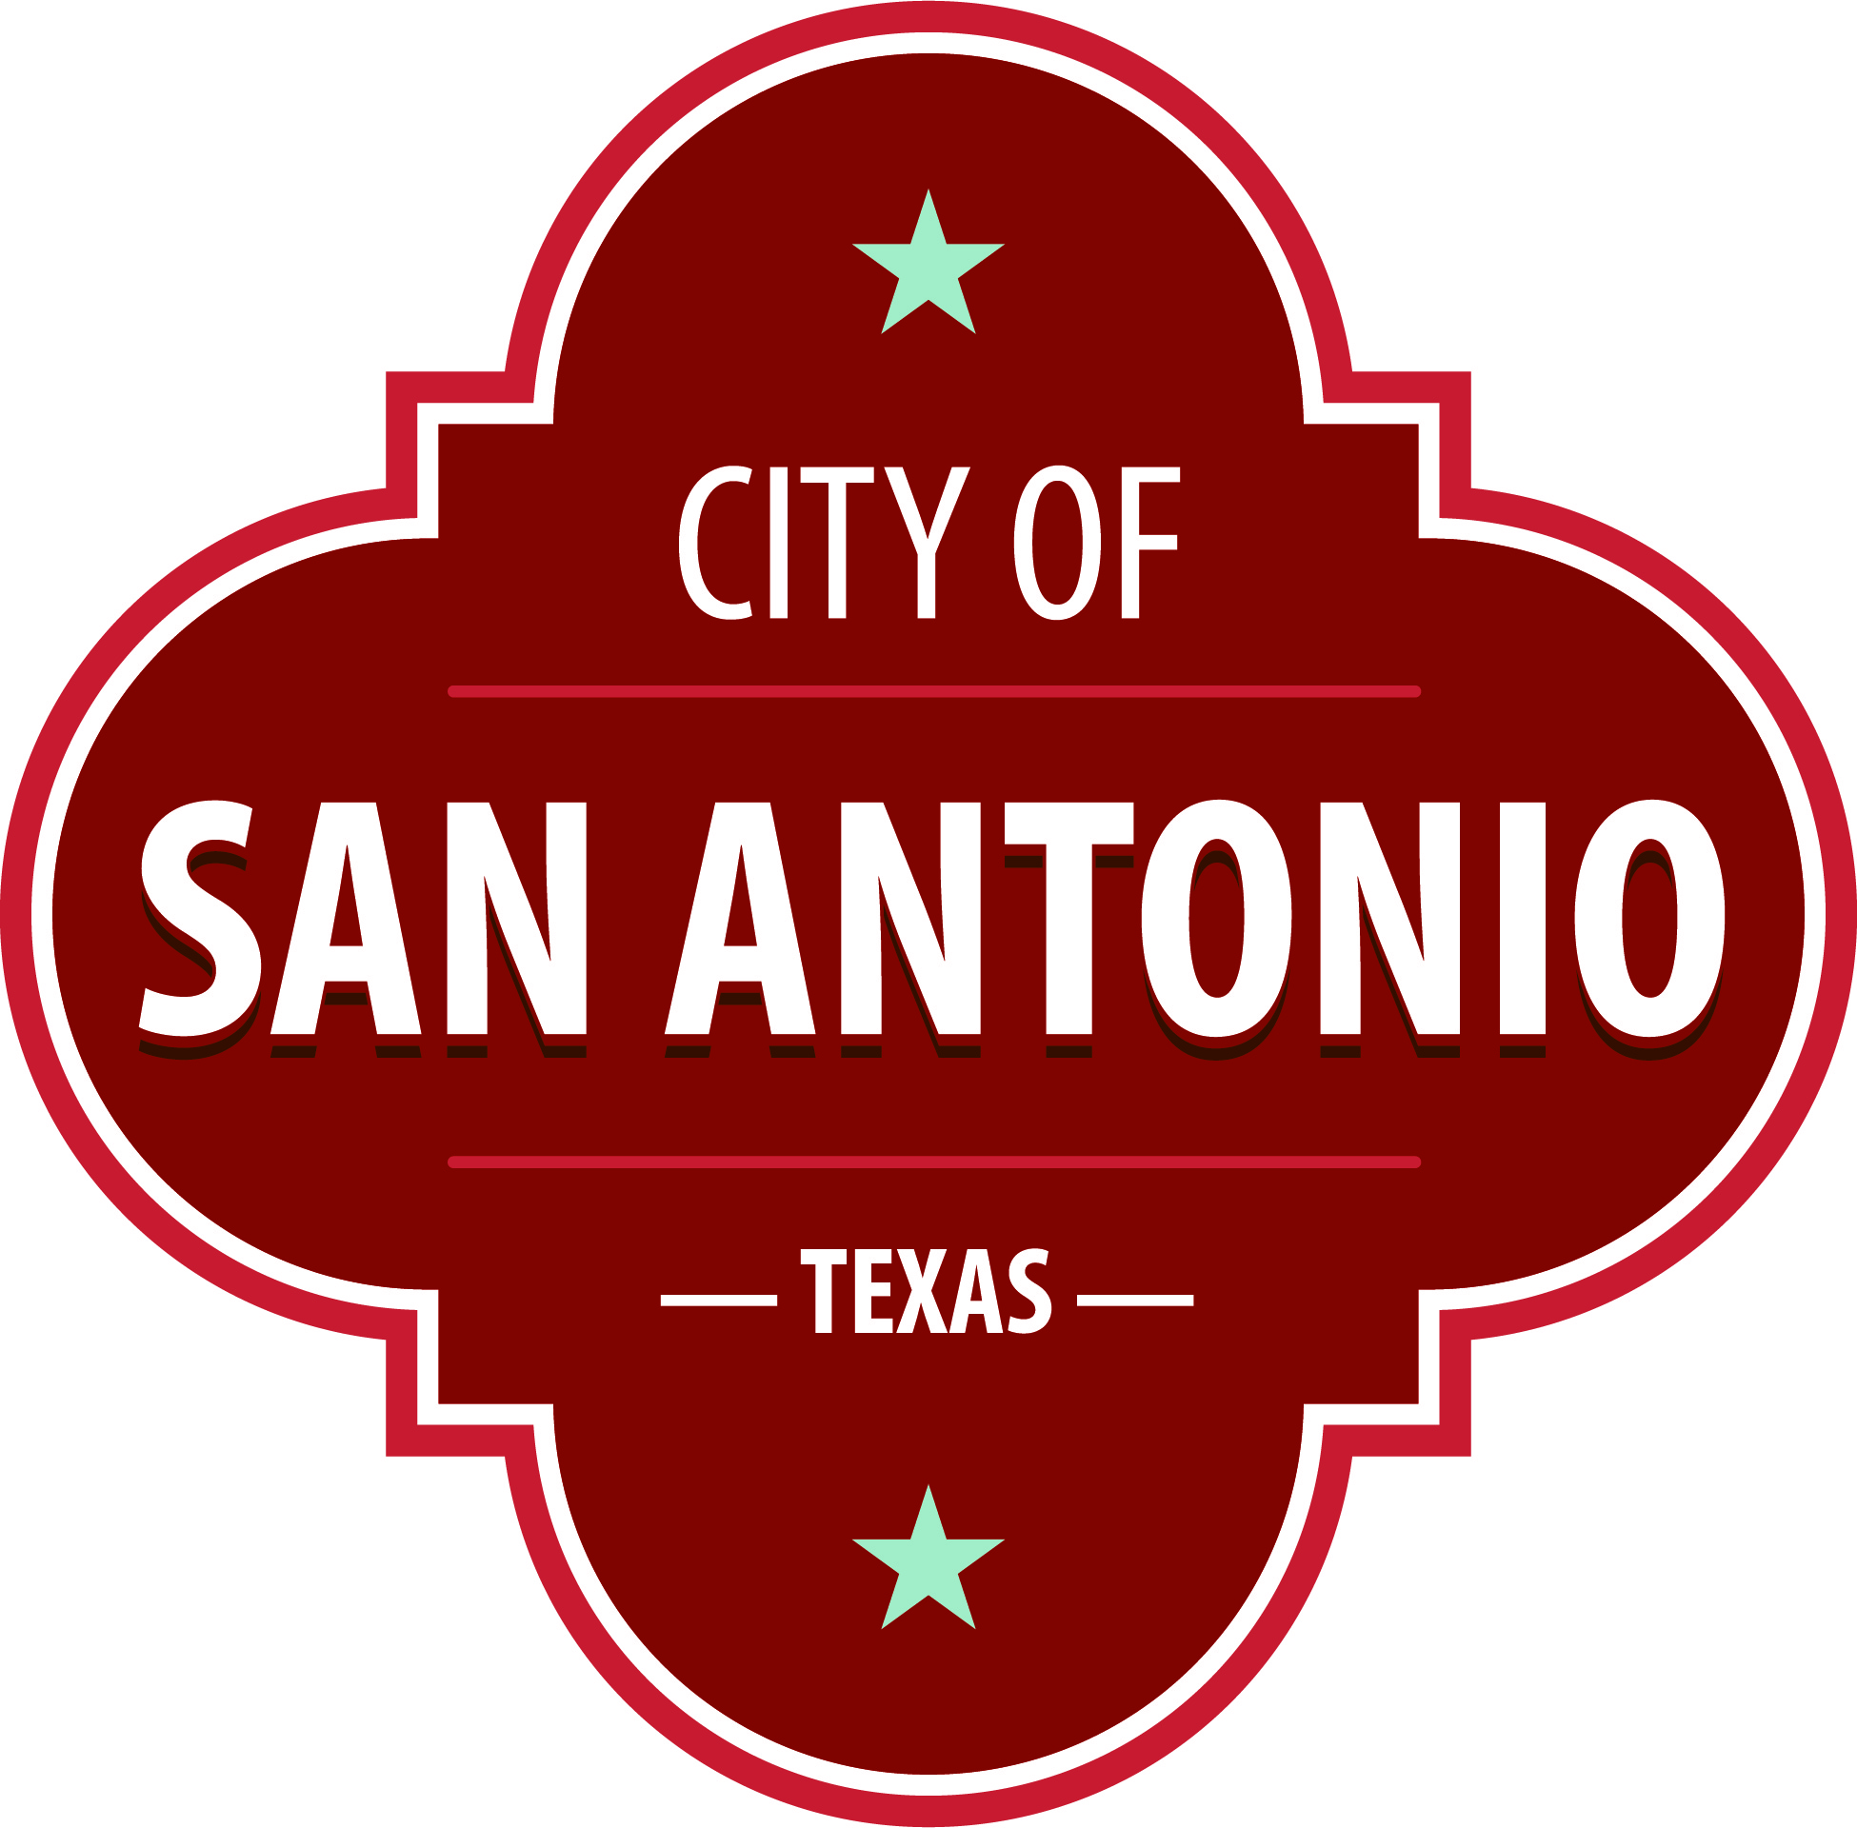
AGENDA
Linear Creekway Parks Advisory Board
Tuesday, August 30, 2022 | 6:00 PM | Granados Adult Senior Center

MEETING OF THE LINEAR CREEKWAY PARKS ADVISORY BOARD WILL BE HELD AT THE GRANADOS ADULT AND SENIOR CENTER, 500 FREILING, SAN ANTONIO, TEXAS 78213 AT THE ABOVE REFERENCED TIME AND DATE.
Members of the public may provide comment on any agenda item, consistent with procedural rules governing the Board meetings and state law. Public comments may be provided as follows:
1. In – Person: Sign up to speak in-person prior to the start of the meeting via the Public Comments SignUp sheet available in the meeting room location. Each speaker will be allowed a maximum of three minutes.
2. Written: Provide written comments (up to 300 words maximum) via email by 4:00 p.m. on the date of the meeting to cynthia.uribe@sanantonio.gov. Please include full name and address. General comments unrelated to specific agenda items will be read during the Public Comments portion of the agenda.

Once quorum is established, the Linear Creekway Advisory Board shall consider the following:
Approval of Minutes
1. | Approval of the minutes from the Linear Creekway Parks Advisory Board meeting on July 26, 2022.

Public Comments

Briefing and Possible Action on the following items
2. | Board Member Report - Linear Creekway Parks Development Program.

3. | French Creek Greenway Trail Update - Chris Arrigo, Parks and Recreation Department.

4. | Staff Report - Linear Creekway Parks Development Program.

ADJOURNMENT

At any time during the meeting, the Linear Creekway Parks Advisory Board may meet in executive session for consultation with the City Attorney's Office concerning attorney client matters under Chapter 551 of the Texas Government Code.
LINEAR CREEKWAY PARKS ADVISORY BOARD MEMBERS
District 1 – Vacant
District 2 – Sue Calberg
District 3 – Leslie Provence
District 4 – Randy Preissig
District 5 – Chris Yanez
District 6 – Myrl Britten
District 7 – Greg Hammer, Chair
District 8 – Rob McDaniel
District 9 – John Kent, Vice Chair
District 10 – Sherri Dugas
Mayoral – Elaine Kearney
ACCESS STATEMENT
The City of San Antonio ensures meaningful access to City meetings, programs and services by reasonably providing: translation and interpretation, materials in alternate formats, and other accommodations upon request. To request these services call (210) 207-7268 or Relay Texas 711 or by requesting these services online at https://www.sanantonio.gov/gpa/LanguageServices. Providing at least 72 hours’ notice will help to ensure availability.
DECLARACIÓN DE ACCESO
La Ciudad de San Antonio garantiza un acceso significativo a las reuniones, los programas y los servicios de la Ciudad proporcionando razonablemente; traduccion e interpretacion, materiales en formatos alternativos y otras adaptaciones a pedido, Para solicitar esto servicios llame al (210) 207-7268 o Relay Texas 711 o solicite esto servicios en linea en https://www.sananotnio.gov/gpa/LanguageServices. Proporcionar un aviso de al menos 72 horas ayudara a garantizar la disponibilidad.
Posted on: 08/25/2022 11:13 AM

