City of San Antonio
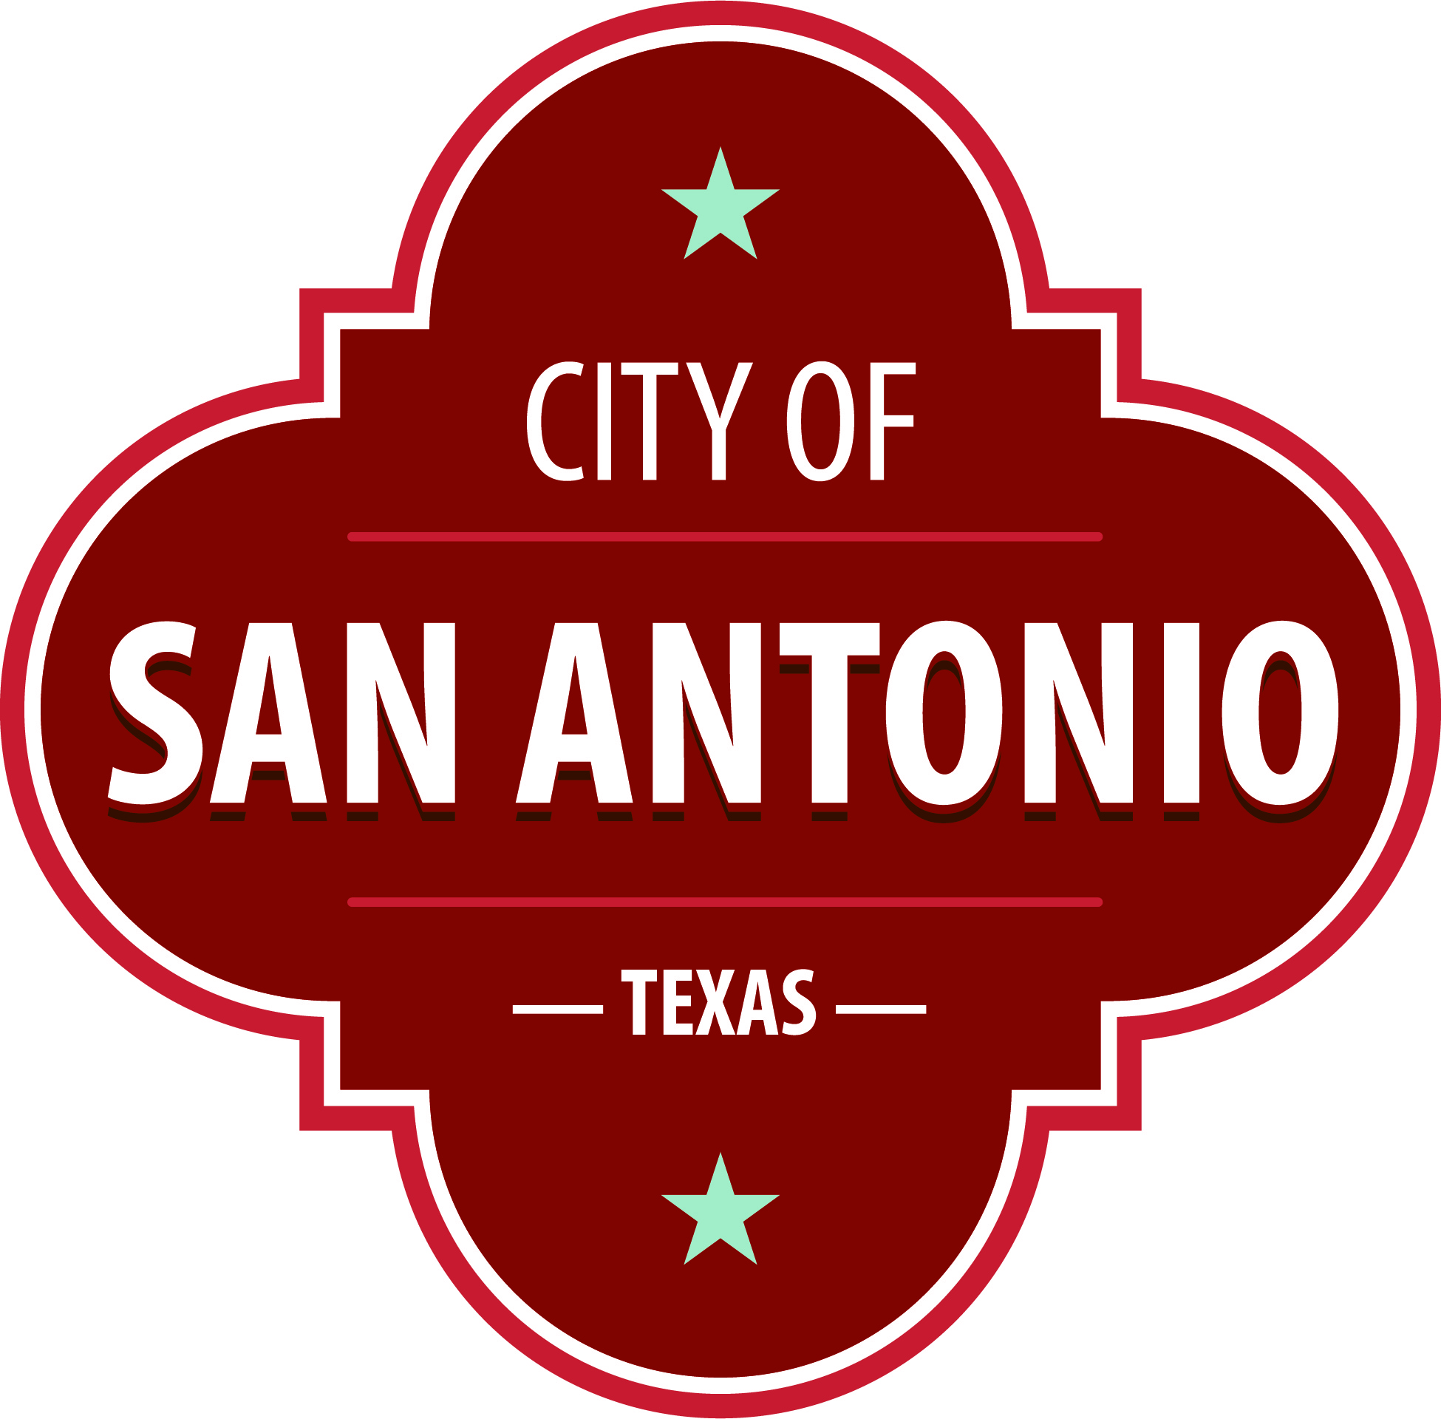
AGENDA
Commission on Veterans Affairs (VAC)
Monday, September 19, 2022 | 6:30 PM | University Center Conference Room B, St. Mary's University, One Camino Santa Maria, San Antonio, TX 78228

The Commission on Veterans Affairs (VAC) will hold its regular meeting in the University Center Conference Room B, St. Mary's University, One Camino Santa Maria, San Antonio, TX 78228 beginning at 6:30 PM. Once convened, the Commission on Veterans Affairs (VAC) will take up the following items no sooner than the designated times.
Once a quorum is established, the Commission on Veterans Affairs (VAC) shall consider the following:
Approval of Minutes
Approval of the minutes from the meeting on August 15, 2022.

Public Comments

Briefing and Possible Action on the following items
1. Updates and Administration:
a. Chair Opening Comments
b. D7/ Staff liason introduction of hosting organization
c. Secretary Brief
d. Districts Briefs (in order from D1 – D10)
e. Co-Chair (D4) Brief
f. Chair (Mayoral) Brief
g. Staff liaison administrative items overview and due-outs
i. Upcoming meetings’ host and focus topics
ii. Staff liaison updates on any projects / initiatives related to districts
2. Hidden Heroes Committee Update (Sponsor: D4/ Co-Chair)
a. Last Meeting Recap
b. Heroes and History Makers Gala
3. By-laws Committee Update (Sponsor: D8)
a. Current status
4. Focus Topic and Guest Speaker: St. Mary’s University Veteran & Military Programs (Sponsor: D7; Guest: Mr. Andrew Lyons, Coordinator Veteran & Military Affairs, St. Mary’s University)
5. Strategic Plan Discussion
a. Goals for VAC
b. Committees to align with goals
6. Closing Comments (Chair)
a. Next meet: October 17, 2022 hosted by Chair

At any time during the meeting, the Commission on Veterans Affairs (VAC) may meet in executive session for consultation with the City Attorney's Office concerning attorney client matters under Chapter 551 of the Texas Government Code.
ACCESS STATEMENT
The City of San Antonio ensures meaningful access to City meetings, programs and services by reasonably providing: translation and interpretation, materials in alternate formats, and other accommodations upon request. To request these services call (210) 207-7268 or Relay Texas 711 or by requesting these services online at https://www.sanantonio.gov/gpa/LanguageServices. Providing
at least 72 hours’ notice will help to ensure availability.

Posted on: 09/15/2022 03:56 PM

