City of San Antonio
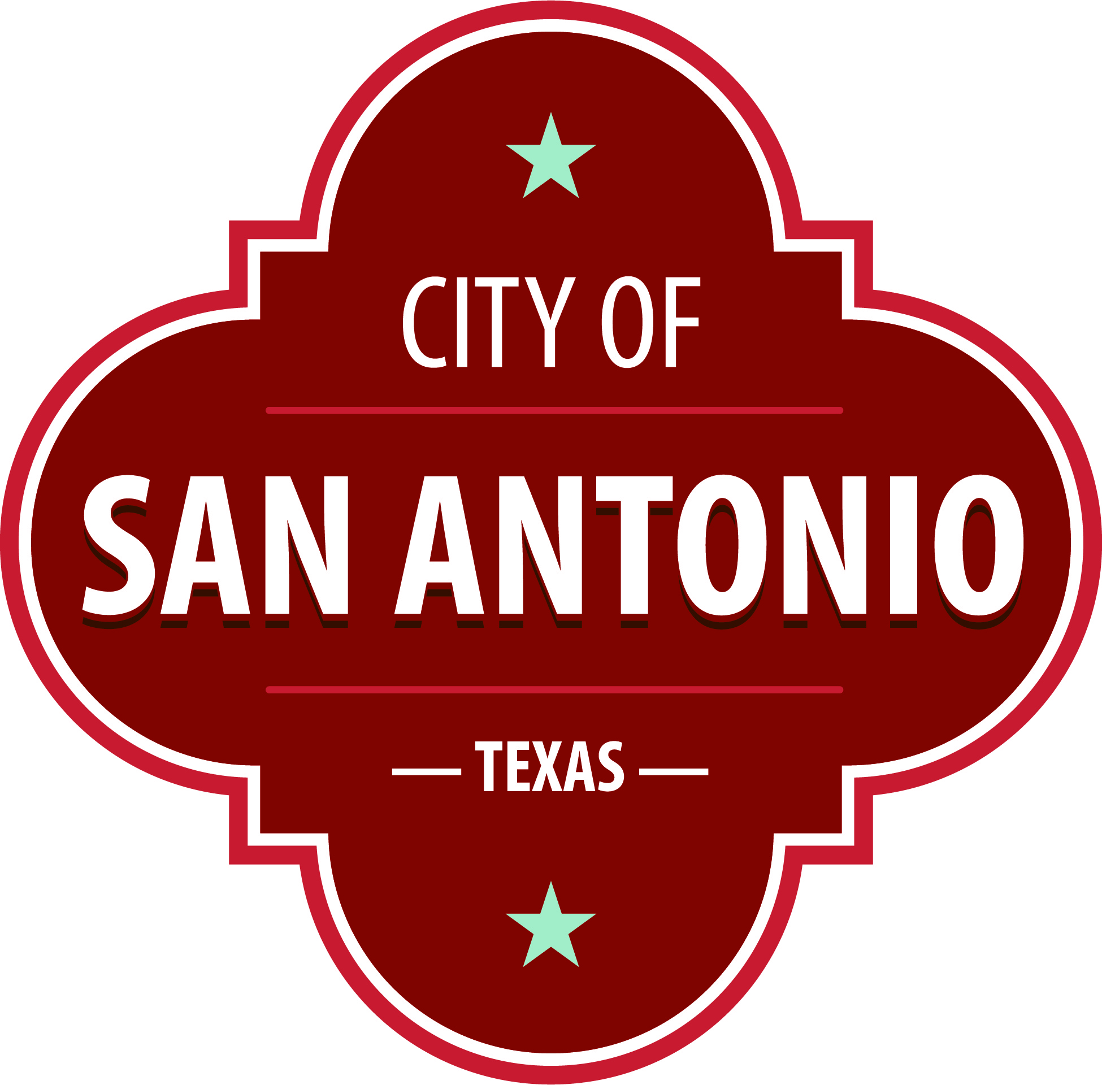
AGENDA
San Antonio Arts Commission: Public Art Committee
Tuesday, October 4, 2022 | 10:00 AM | Videoconference

The San Antonio Arts Commission: Public Art Committee will hold its regular meeting via videoconference beginning at 10:00 AM. Once convened, the San Antonio Arts Commission: Public Art Committee will take up the following items no sooner than the designated times.
The meeting will be available to the public via WebEx at:
https://sanantonio.webex.com/sanantonio/onstage/g.php?MTID=e683441afbf7fcc1d8e783fb9f66179c4
For call-in users: US Toll +1-415-655-0001; Access code: 2456 140 1399
Citizens that wish to speak before the San Antonio Arts Commission: Public Art Committee must email their request to PublicArt.SanAntonio@sanantonio.gov by 9 AM on Tuesday, October 4, 2022, and specify the agenda item they wish to speak on. If Citizen does not specify an agenda item, they will be heard during Public Comments section. Each individual/organization will have a maximum of 3 minutes to speak. Those not registered to speak will be given the opportunity to address the San Antonio Arts Commission: Public Art Committee at the next regularly-scheduled meeting.
Call to Order

Approval of Minutes
1. | Approval of the minutes from the San Antonio Arts Commission: Public Art Committee meeting on September 6, 2022

Briefing and Possible Action on the following items
2. | Zona Cultural Sculptures (Artist Selection)

3. | Commerce & Frio Gateway Sculptures (Final Design)

4. | River Walk Curated Tour (Briefing)

Public Comments

Announcements and Reports

ADJOURNMENT

At any time during the meeting, the San Antonio Arts Commission: Public Art Committee may meet in executive session for consultation with the City Attorney's Office concerning attorney client matters under Chapter 551 of the Texas Government Code.
ACCESS STATEMENT
The City of San Antonio ensures meaningful access to City meetings, programs and services by reasonably providing: translation and interpretation, materials in alternate formats, and other accommodations upon request. To request these services call (210) 206-ARTS or Relay Texas 711 or by requesting these services online at https://www.sanantonio.gov/gpa/LanguageServices. Providing at least 72 hours’ notice will help to ensure availability.
Posted on: 09/30/2022 05:25 PM

