City of San Antonio
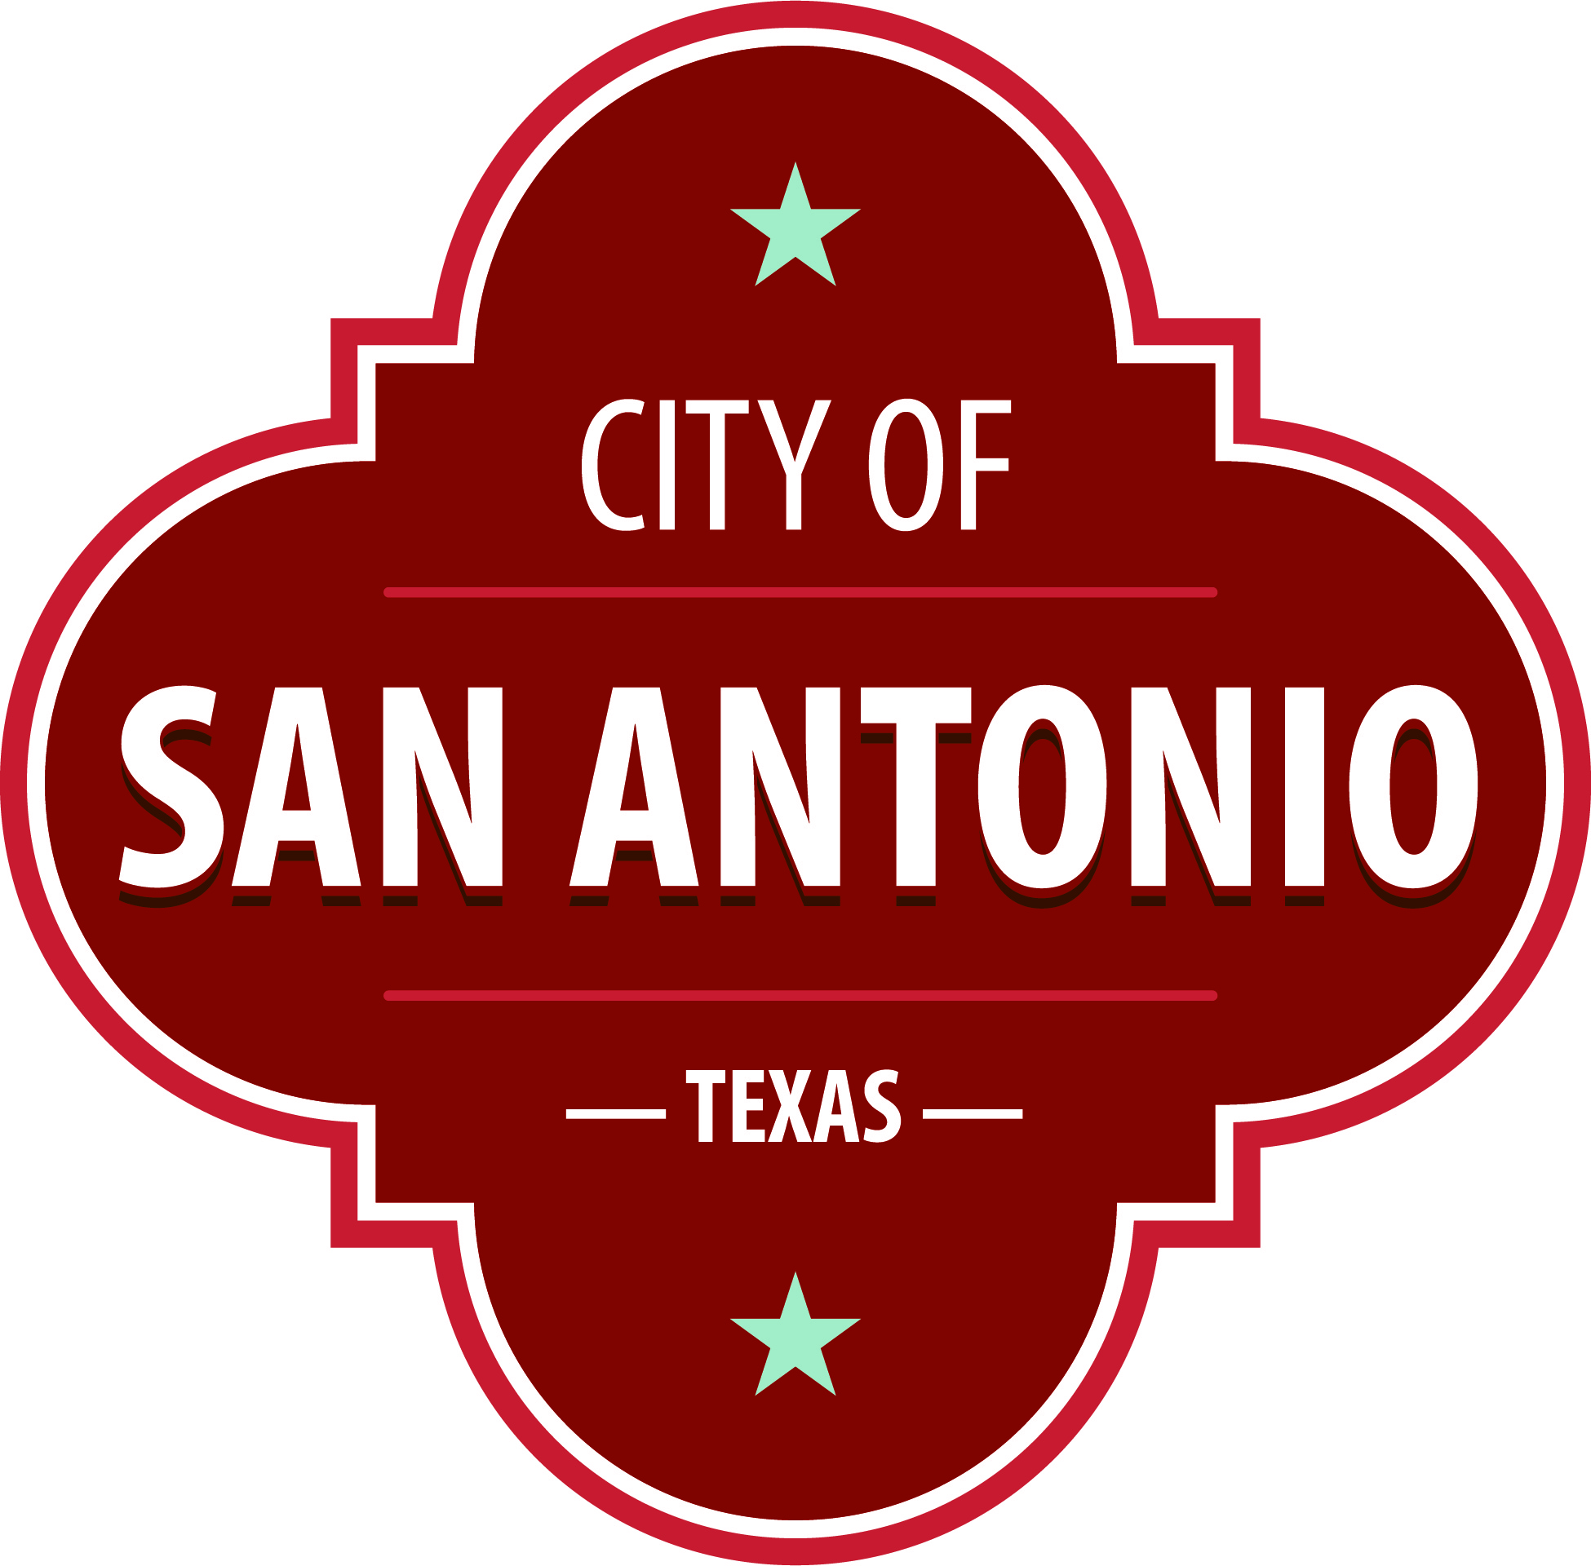
AGENDA
San Antonio Youth Commission - May Meeting
Saturday, May 18, 2024 | 10:00 AM | City Tower, 9th Floor  100 W. Houston Street  San Antonio, TX 78205

In compliance with the Texas Open Meeting Act, the Department of Human Services San Antonio Youth Commission will hold an open meeting at City Tower, 9th Floor, 100 W. Houston Street, San Antonio, TX 78205 on 18 May 2024 at 10:00 AM.
The commission meetings are open to the public. Members of the public can attend the commission meetings and comment on items on the agenda.
Public Comment: Citizens can sign up before the meeting starts to speak on an agenda item. Citizens who wish to have their public comments read at the next meeting must submit their comments at least 24 hours prior to the meeting. Citizens who wish to submit comments and have them read at the meeting, may send them via email or by leaving a message. Please include your full name, address, item you are addressing and your comments.
Email: Please email the comments to camryn.blackmon@sanantonio.gov. Emails will be read at the meeting.
Voicemail: You may call (210) 207-1763 and leave a voicemail. Messages will be transcribed and read at the meeting.
Approval of Minutes
1. | Approval of the minutes from the San Antonio Youth Commission meeting on March 23, 2024.

Public Comments

Briefing and Possible Action on the following items
2. | City Council District 5 Councilmember Teri Castillo

3. | Request for FY25 Budget Meeting for Youth

4. | Update on Microgrant Awards from City Staff

5. | Media and Speaking Engagement Policy

6. | Recap of TeensDaySA

7. | Update on Teen Mental Health Survey

8. | Goals for the 2024-2025 Term

At any time during the meeting, the San Antonio Youth Commission - May Meeting may meet in executive session for consultation with the City Attorney's Office concerning attorney client matters under Chapter 551 of the Texas Government Code.
ACCESS STATEMENT
The City of San Antonio ensures meaningful access to City meetings, programs and services by reasonably providing: translation and interpretation, materials in alternate formats, and other accommodations upon request. To request these services call (210) 207-1467 or Relay Texas 711 or by requesting these services online at https://www.sanantonio.gov/gpa/LanguageServices. Providing at least 72 hours’ notice will help to ensure availability.
Posted on: 05/13/2024 12:36 PM

