City of San Antonio
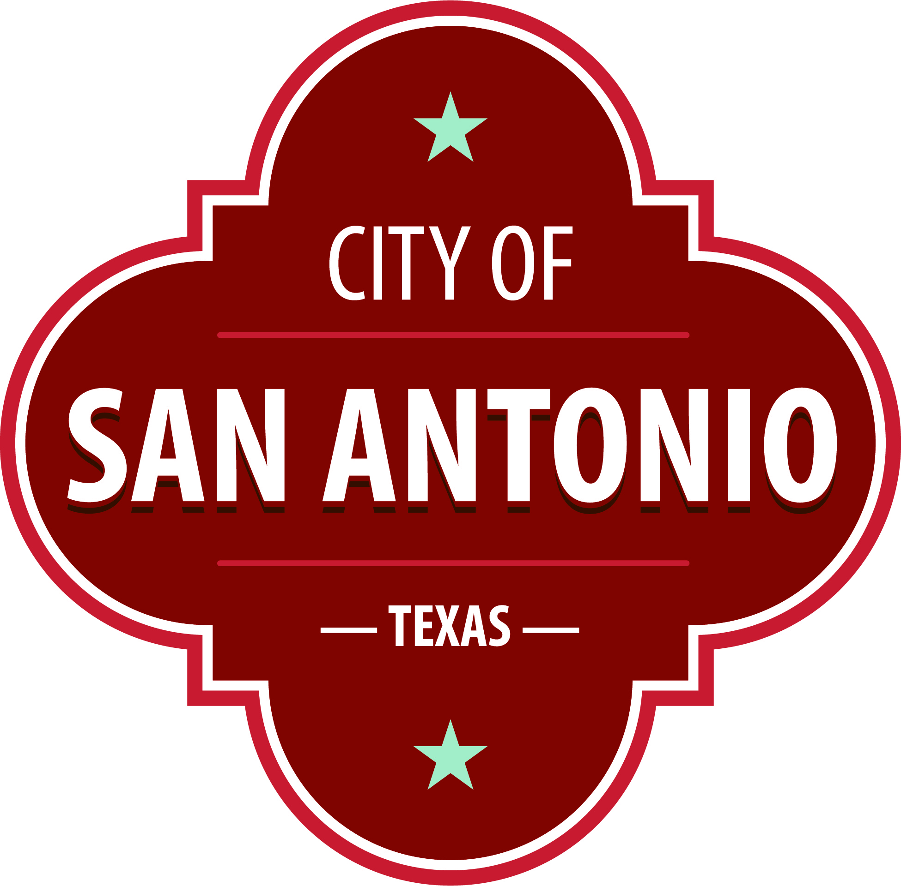
AGENDA
San Antonio Youth Commission
café college
San Antonio, Texas 78204
Saturday, January 8, 2022 | 10:00 AM | 131 El Paso St., San Antonio, Texas 78204

In compliance with the Texas Open Meeting Act, the San Antonio Youth Commission will hold an open meeting at 131 El Paso St., San Antonio, Texas 78204 on 08 January 2022, at 10:00 AM.
The commission meetings are open to the public. Members of the public can attend the commission meetings and comment on items on the agenda.
Public Comment: Citizens can sign up before the meeting starts to speak on an agenda item. Citizens who wish to have their public comments read at the next meeting must submit their comments at least 24 hours prior to the meeting. Citizens who wish to submit comments and have them read at the meeting, may send them via email or by leaving a message. Please include your full name, address, item you are addressing and your comments.
- Email: Please email the comments to jemm.morris@sanantonio.gov. Emails will be read at the meeting.
- Voicemail: You may call (210) 207-1467 and leave a voicemail. Messages will be transcribed and read at the meeting.
Approval of Minutes

Public Comments

Briefing and Possible Action on the following items
1. | Review of SA Speak up Teen Mental Health Survey Questions

DISABILITY ACCESS STATEMENT
This meeting site is wheelchair accessible. Auxiliary Aids and Services, including Deaf interpreters, must be requested forty-eight [48] hours prior to the meeting.
For assistance, call (210) 207-1467.
Posted on: 01/05/2022 03:53 PM

