City of San Antonio
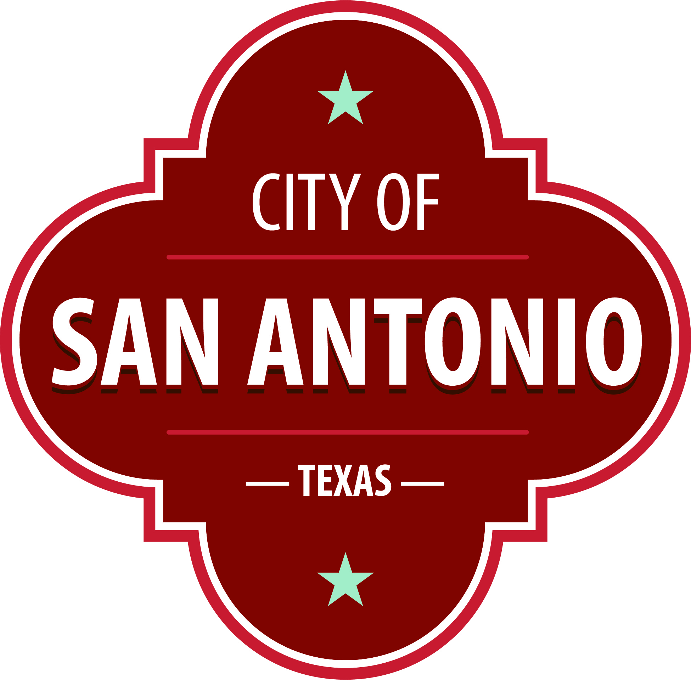
AGENDA
San Antonio Arts Commission: Public Art Committee
Thursday, January 6, 2022 | 10:00 AM | Video Conference

The San Antonio Arts Commission: Public Art Committee will hold its regular meeting via video conference beginning at 10:00 AM. Once convened, the San Antonio Arts Commission: Public Art Committee will take up the following items no sooner than the designated times.
The meeting will be available to the public via WebEx at:
https://sanantonio.webex.com/sanantonio/onstage/g.php?MTID=ee9db2aa0e2e5dfc027fc045359537e75
For call-in users: US Toll +1-415-655-0001; Access code: 2460 184 4613
Please note, these meetings are designed to be video conference. If you join by using audio only, there may be information on screen that you will not have access to. For the best experience, we recommend downloading the WebEx Meetings Application.
Citizens that wish to speak before the San Antonio Arts Commission: Public Art Committee must email their request to PublicArt.SanAntonio@sanantonio.gov by 9am on Thursday, January 6, 2022, and specify the agenda item they wish to speak on. If Citizen does not specify an agenda item, they will be heard during Public Comments section. Each individual/organization will have a maximum of 3 minutes to speak. Those not registered to speak will be given the opportunity to address the San Antonio Arts Commission: Public Art Committee at the next regularly-scheduled meeting.
Once a quorum is established, the following items will be considered no sooner than the
designated times:
Call to Order/Roll Call

Approval of Minutes
1. | Approval of the minutes from the San Antonio Arts Commission: Public Art Committee meeting on December 7, 2021.

Briefing and Possible Action on the following items
2. | Enrique Barrera Parkway (Concept Design)

3. | FY22 Annual Call for Artists and Arts Professionals

4. | MLK Park Installation

Public Comments

Announcements and Reports
2022-2027 Bond Public Art

ADJOURNMENT

At any time during the meeting, the San Antonio Arts Commission: Public Art Committee may meet in executive session for consultation with the City Attorney's Office concerning attorney client matters under Chapter 551 of the Texas Government Code.

ACCESSIBILITY STATEMENT
Auxiliary aids and services, including Deaf interpreters, must be requested forty-eight [48] hours prior to the meeting. For assistance, call 206-ARTS (2787) or 711 (Texas Relay Service for the Deaf).

