City of San Antonio
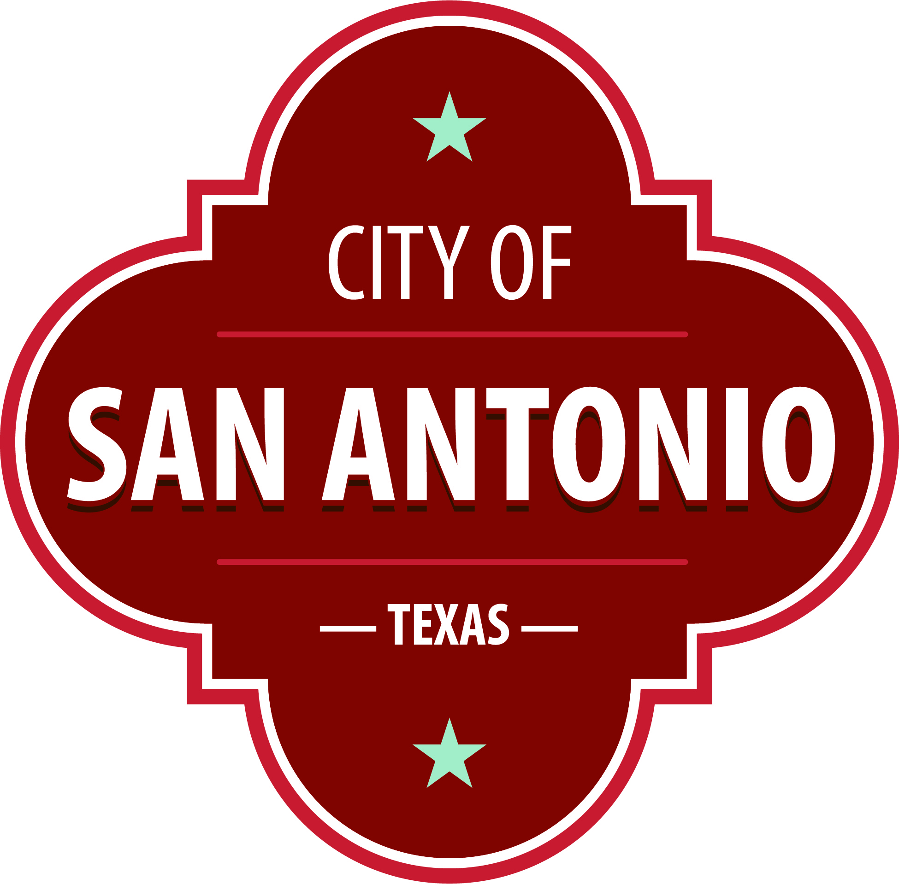
AGENDA
City Commission on Veterans Affairs (VAC)
Monday, November 15, 2021 | 3:00 PM | City of San Antonio, District 4 Field Office, located at 5102 Old Pearsall Road, San Antonio, TX 78242

The City Commission on Veterans Affairs (VAC) will hold its regular meeting in the City of San Antonio, District 4 Field Office, located at 5102 Old Pearsall Road, San Antonio, TX 78242 beginning at 3:00 PM. Once convened, the City Commission on Veterans Affairs (VAC) will take up the following items no sooner than the designated times.
Once a quorum is established, the City Commission on Veterans Affairs (VAC) shall consider the following:
Nation Anthem

Public Comments

Approval of Minutes
1. | City Commission on Veterans Affairs 26 October 2021 Meeting Minutes

Briefing and Possible Action on the following items
2. | Veterans Day Events Recap

3. | Veterans Day Parade 2022

4. | CoSA Parks and Trail Heads  A. District 8 Park Trail Head Discussion  B. OMVA representative to discuss Greenways around JBSA

5. | Bylaws SubCommittee  A. Updates  B. Timeline

6. | Elizabeth Dole Foundation Subcommittee  A. Request self-nominations for the Elizabth Dole Foundation (EDF) Hidden Heroes City (HHC) subcommittee.  B. Establish a subcommittee meeting date.

7. | VAC Calendar  A. Determine next years meeting dates  B. Disccuss Holiday Social  C. OMVA to provide brief on VAC digital Veterans Support calendar  D. Determine two VAC dates for City Photography

8. | Special Interest Focus Topic: Women Veteran Services  A. D4 to lead discuss as focus topic and meeting host  B. OMVA representative to provide supplemental material  C. Discussion of situation  D. Discussion of resources  E. Discussion of gaps  F. Discussion of ways ahead to mitigate gaps

At any time during the meeting, the City Commission on Veterans Affairs (VAC) may meet in executive session by videoconference for consultation with the City Attorney's Office concerning attorney client matters under Chapter 551 of the Texas Government Code.

DISABILITY ACCESS STATEMENT
This meeting site is wheelchair accessible. The Accessible Entrance is located at the Municipal Plaza Building / Main Plaza Entrance. Auxiliary Aids and Services, including Deaf interpreters, must be requested forty-eight [48] hours prior to the meeting. For assistance, call (210) 207-7268 or 711 Texas Relay Service for the Deaf.

Intérpretes en español estarán disponibles durante la junta del consejo de la ciudad para los asistentes que lo requieran. También se proveerán intérpretes para los ciudadanos que deseen exponer su punto de vista al consejo de la ciudad. Para más información, llame al (210) 207-7253

