City of San Antonio
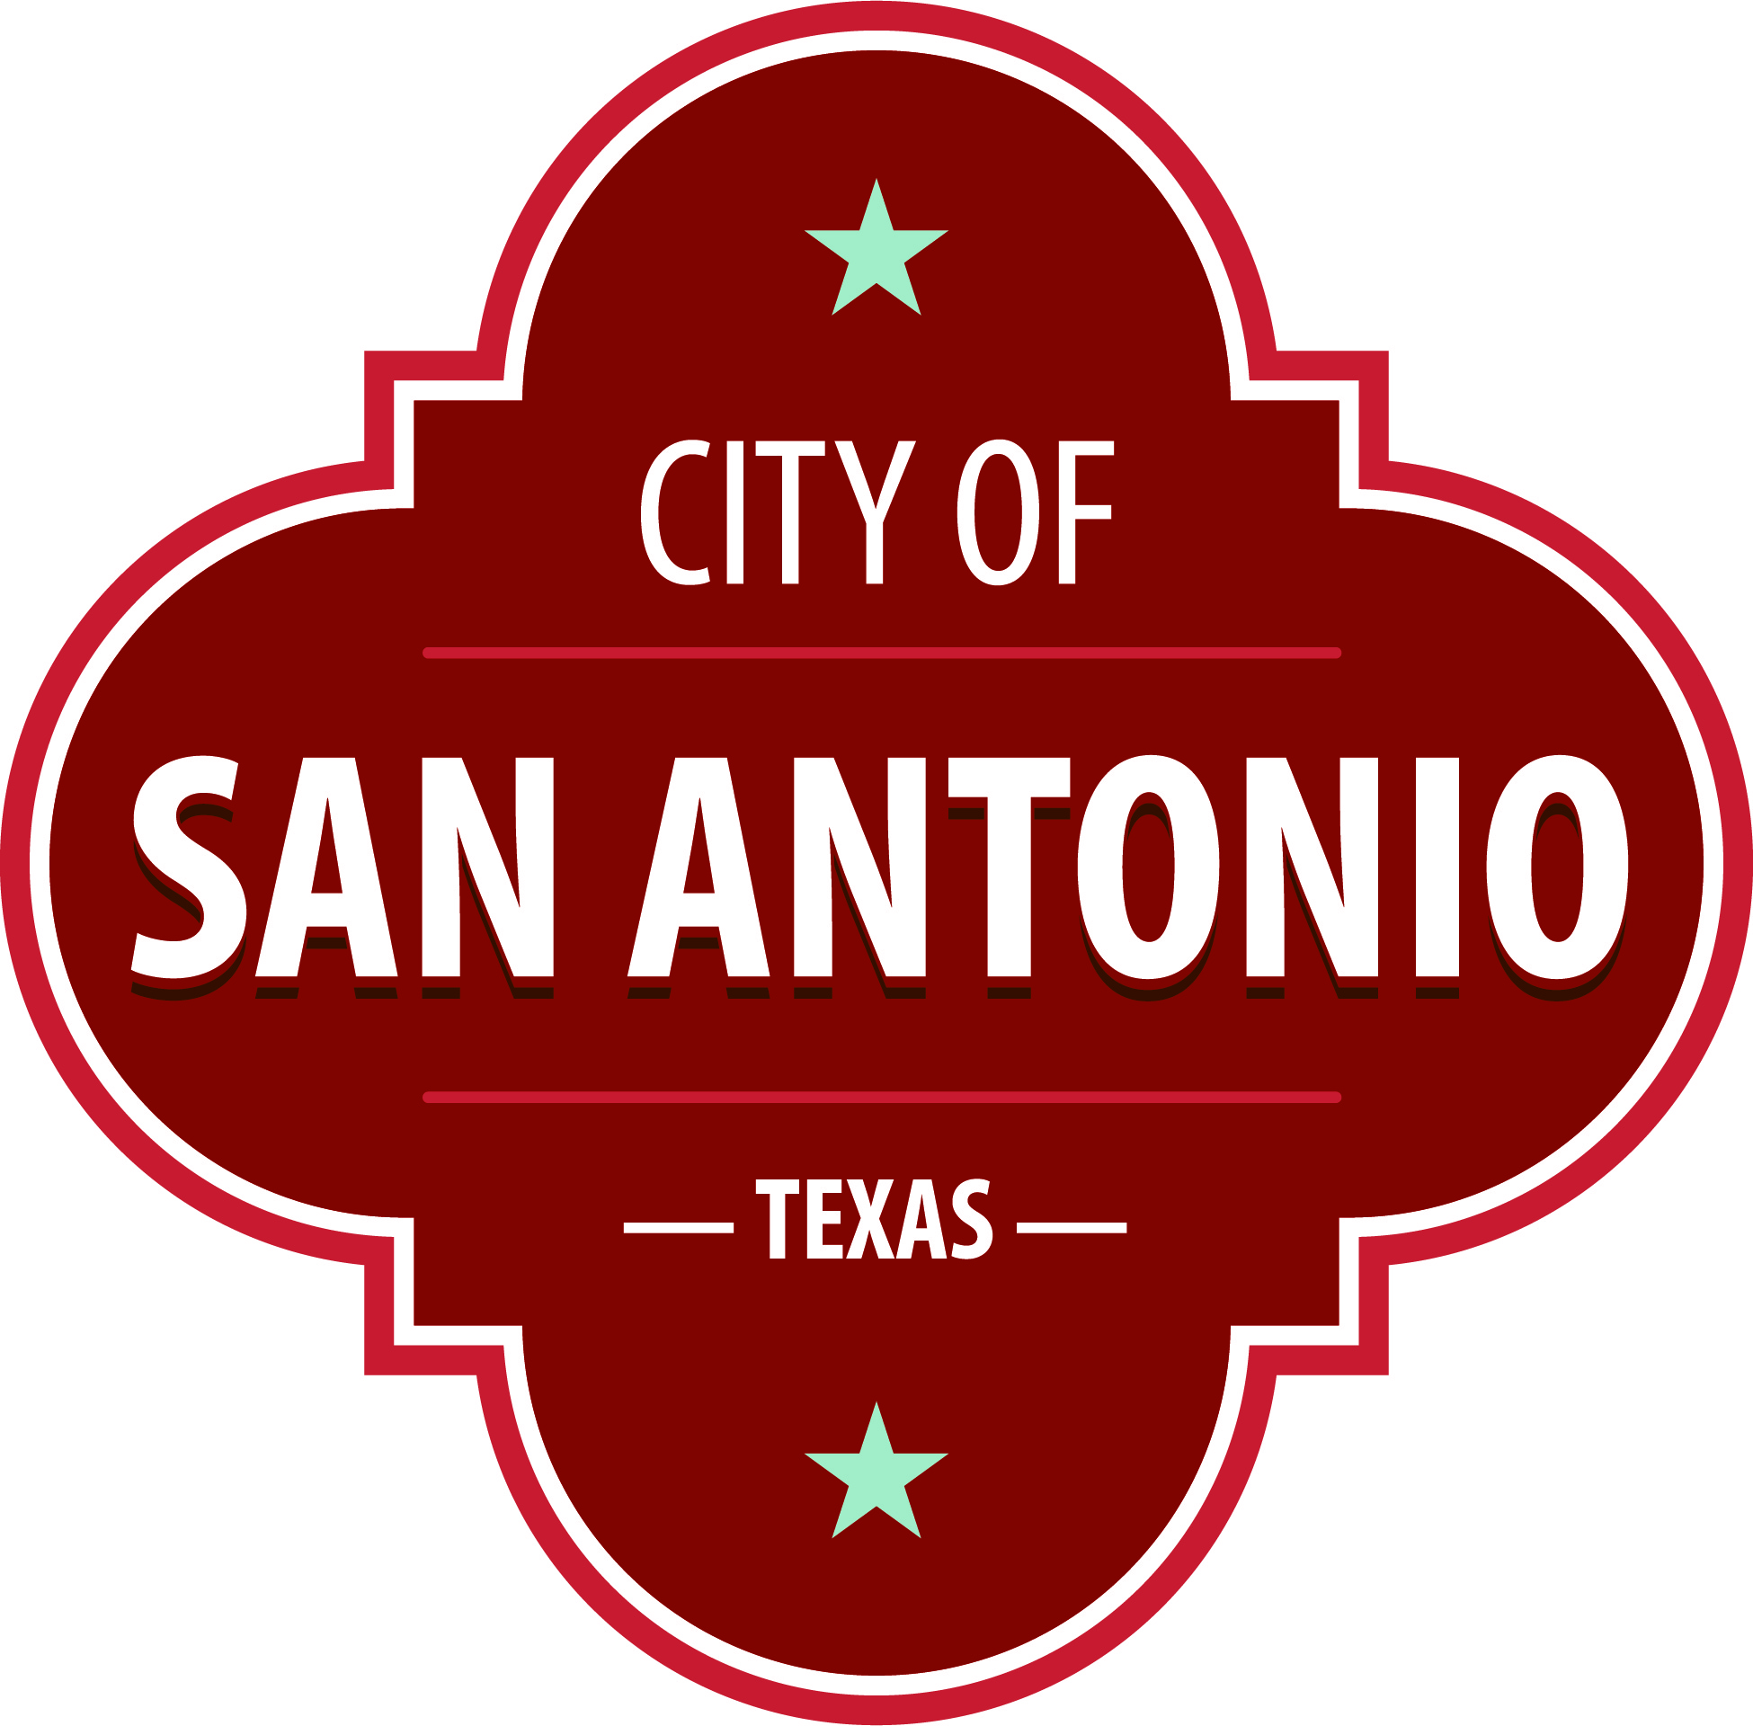
AGENDA
Parks and Recreation Board
Monday, May 23, 2022 | 5:30 PM | Municipal Plaza
The Parks and Recreation Board will hold its regular meeting in the Municipal Plaza Building located at 114 W. Commerce, San Antonio, Texas, 78205 beginning at 5:30 PM. Members of the public may provide comment on any agenda item, consistent with procedural rules governing the Board meetings and state law. Public comments may be provided as follows:
- In-Person: Sign up to speak in-person prior to the start of the meeting via the Public Comments Sign-Up sheet available in the meeting room location. Each speaker will be allowed a maximum of three minutes.
- Written: Provide written comments (up to 300 words maximum) via email by 4:00 p.m. on the date of the meeting to Ryan.Evans@sanantonio.gov. Please include full name and address. General comments unrelated to specific agenda items will be read during the Public Comments portion of the agenda.
Once quorum is established, the Parks and Recreation Board shall consider the following:
Approval of Minutes
1. | Approval of the minutes from the Parks and Recreation Board meeting on March 28, 2022.

Public Comments

Briefing and Possible Action on the following items
2. | Briefing Regarding Partnership with Kumamoto, Japan on Urban Green Space.

3. | Briefing Regarding the Island at Elmendorf Lake Park.

4. | Briefing Regarding 2017 Bond Project at Brackenridge Park Community Engagement Process.

5. | Parks and Recreation Director's Report - General Departmental Updates.

ADJOURNMENT

At any time during the meeting, the Parks and Recreation may meet in executive session for consultation with the City Attorney's Office concerning attorney client matters under Chapter 551 of the Texas Government Code.
Parks and Recreation Board Members
District 1 – Erik Sanden
District 2 – Carla Walker
District 3 – Lillian Rivera
District 4 – M. Kathy Luna (Vice-Chair)
District 5 – Agapita Jaramillo
District 6 – Melinda Smith
District 7 – Alejandro Soto
District 8 – Charles Saxer
District 9 – Vacant
District 10 – Allison Cohen (Chair)
Mayoral – Jeanette Honermann
DISABILITY ACCESS STATEMENT
This meeting site is wheelchair accessible. The Accessible Entrance is located at the Municipal Plaza Building/Main Plaza Entrance. Auxiliary Aids and Services, including Deaf interpreters, must be requested forty-eight [48] hours prior to the meeting. For assistance, call (210) 207-7268 or 711 Texas Relay Service for the Deaf.
Intérpretes en español estarán disponibles durante la junta del consejo de la ciudad para los asistentes que lo requieran. También se proveerán intérpretes para los ciudadanos que deseen exponer su punto de vista al consejo de la ciudad. Para más información, llame al (210) 207-7253.
Posted on: 05/20/2022 03:25 PM

