City of San Antonio
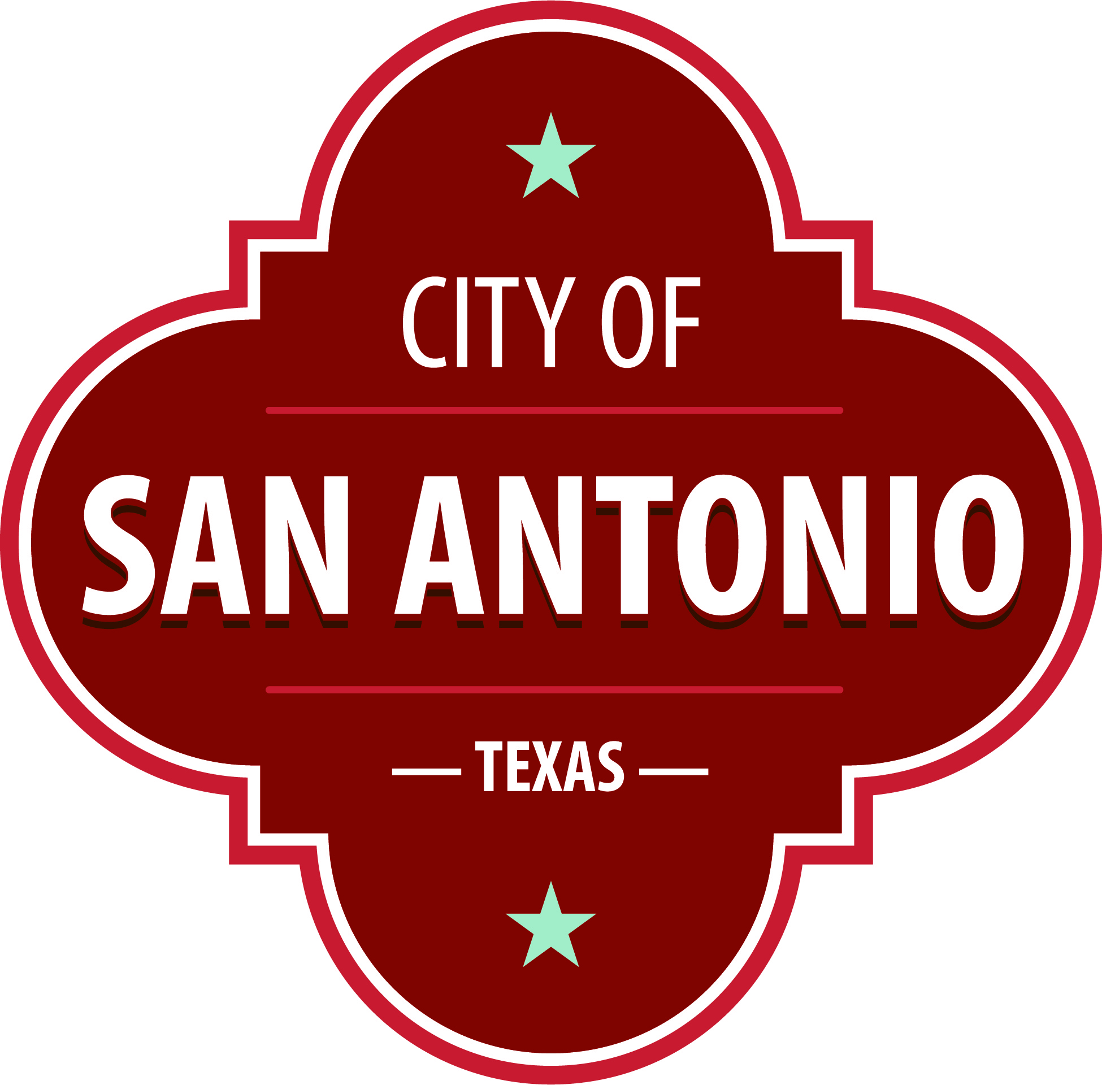
AGENDA
San Antonio Arts Commission: Public Art Committee
Tuesday, May 3, 2022 | 10:00 AM | Plaza de Armas Building, 115 Plaza de Armas

The San Antonio Arts Commission: Public Art Committee will hold its regular meeting in the Plaza de Armas Building, 115 Plaza de Armas beginning at 10:00 AM. Once convened, the San Antonio Arts Commission: Public Art Committee will take up the following items no sooner than the designated times.
Citizens that wish to speak before the San Antonio Arts Commission must be signed in before the meeting and specify the agenda item they wish to speak on. If Citizen does not specify an agenda item, they will be heard during Public Comments section. Each individual/organization will have a maximum of 3 minutes to speak. Those not registered to speak will be given the opportunity to address the San Antonio Arts Commission: Public Art Committee at the next regularly-scheduled meeting.
Call to Order

Approval of Minutes
1. | Approval of the minutes from the San Antonio Arts Commission: Public Art Committee meeting on March 1, 2022

Briefing and Possible Action on the following items
2. | Blossom Park (Project Initiation)

3. | Fire Station Replacement #24 (Project Initiation)

4. | Aviation Terminal A (Project Initiation)

5. | Plaza de Armas (Artist Selection)

6. | La Villita Maverick Plaza (Concept Design)

7. | Donation of Jose Navarro statue to Texas Historical Commission

8. | The Vibrant Village at City Tower (Installation)

Public Comments

Announcements and Reports
Appointment of Committee Chairs and Members

At any time during the meeting, the San Antonio Arts Commission: Public Art Committee may meet in executive session for consultation with the City Attorney's Office concerning attorney client matters under Chapter 551 of the Texas Government Code.

ACCESSIBILITY STATEMENT
The Plaza de Armas Building is accessible to persons with disabilities. Accessible entrance is located at 115 Plaza de Armas. Auxiliary aids and services, including Deaf interpreters, must be requested forty-eight [48] hours prior to the meeting. For assistance, call 206-ARTS (2787) or 711 (Texas Relay Service for the Deaf).
Posted on: 04/20/2022 09:34 AM

