City of San Antonio
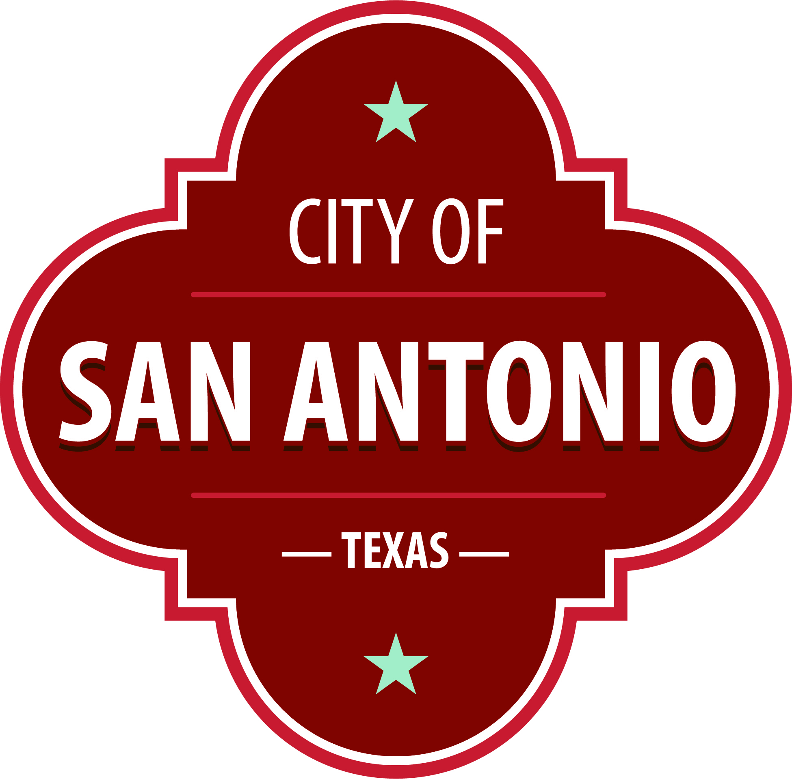
AGENDA
Community Action Advisory Board
Thursday, February 10, 2022 | 3:30 PM | Brady Head Start Building, Galaxy Conference Room, 1227 Brady Blvd, San Antonio, TX 78207

The Community Action Advisory Board will hold its regular meeting in the Brady Head Start Building, Galaxy Conference Room, 1227 Brady Blvd, San Antonio, TX 78207 beginning at 3:30 PM. Once convened, the Community Action Advisory Board will take up the following items no sooner than the designated times.
Members of the public can comment on items on the agenda. To submit comments or sign up to speak, please go to www.sanantonio.gov/agenda and click on the eComment link for instructions. Questions relating to these rules may be directed to the Office of the City Clerk at (210) 207-7253
Once a quorum is established, the Community Action Advisory Board shall consider the following:
Call to Order

Roll Call

Public Comment

Approval of Minutes
1. | Approval of the minutes from the Community Action Advisory Board meeting on December 16, 2021

Public Comments

Briefing and Possible Action on the following items
2. | Review of Community Service Block Grant 2021 Fiscal Report

3. | Review Board Vacancies

4. | Program Updates

5. | Approval of the 2022-2023 Head Start, Early Head Start (EHS), and Early Head Start-Child Care Partnership (EHS-CCP) Program Eligibility, Recruitment, Selection, Enrollment and Attendance (ERSEA) Matrices

6. | Approval of the 2022-2023 Head Start and EHS Program ERSEA policy updates

7. | Approval of the 2022-2023 Head Start and EHS Program ERSEA Recruitment Plan

8. | Approval of 2020-2021 Head Start Program Self-Assessment Report

9. | Approval of the 2022-2023 Head Start, EHS, and EHS-CCP Program Design and Management Policy Updates

10. | Review of Head Start, EHS, and EHS-CCP Beginning of the Year (BOY) Student Outcome Data

11. | Review of Head Start Program Wellness Services

12. | Review of Head Start, EHS, and EHS-CCP Program Monitoring

13. | Review of Head Start, EHS, and EHS-CCP Monthly Program Report

14. | Review of Head Start, EHS, and EHS-CCP Fiscal Report

15. | Review of Head Start Governance Structure and Communication with Economic Workforce Development Committee

16. | Correspondence of the 45 Day Monitoring Review Notification Letter for Focus Area 2 Review

At any time during the meeting, the Community Action Advisory Board may meet in executive session by videoconference for consultation with the City Attorney's Office concerning attorney client matters under Chapter 551 of the Texas Government Code.

DISABILITY ACCESS STATEMENT
This meeting site is wheelchair accessible. The Accessible Entrance is located at the Municipal Plaza Building / Main Plaza Entrance. Auxiliary Aids and Services, including Deaf interpreters, must be requested forty-eight [48] hours prior to the meeting. For assistance, call (210) 207-7268 or 711 Texas Relay Service for the Deaf.

Intérpretes en español estarán disponibles durante la junta del consejo de la ciudad para los asistentes que lo requieran. También se proveerán intérpretes para los ciudadanos que deseen exponer su punto de vista al consejo de la ciudad. Para más información, llame al (210) 207-7253
Posted on: 02/08/2022 01:01 AM

